Mathematical Model of Management of the Integral Risk of Emergency Situation on the Example of Fires

Kravtsiv S.1[0000-0001-6426-3473], Sobol O.1[0000-0002-7133-6519], Komyak V.1[0000-0002-9840-2635]
and Al’boschiy O.2
1 National University of Civil Defence of Ukraine, Kharkiv, Ukraine
kravtsiv1992@gmail.com
2 V.N. Karazin Kharkiv National University, Kharkiv, Ukraine

Abstract. At present, there is a process of reforming the State Service of Ukraine for Emergency Situations, the purpose of which is to ensure an adequate level of safety of the vital activity of the population, its protection against extreme situations, fires and other dangerous events. The result of the reforms should be to ensure an adequate level of the population’s life safety, protection of economic entities and territories from the threat of emergencies, the creation of an effective modern European emergency and emergency prevention system, improvement of the system for responding to fires, emergencies and other dangerous events , reduction of losses of national economy and population in the event of fires, emergencies, dangerous hydrometeorological tech phenomena, creating optimal management unified state system of civil protection and improve its functioning. In this case, an important role is assigned to the application of a risk-oriented approach to justify measures in the field of civil protection. At the same time, there is an actual scientific and practical problem, which consists in the development of the theoretical foundations of man-made man-made, in particular fire risk, since there is practically no scientific research in the modern literature, in which the levers that influence the level of a particular risk would be clearly determined, and models of risk management were built.
One of the tasks, the solution of which will contribute to the solution of this problem, is the construction of a mathematical model and methods for controlling integral fire risk, which will allow the justification of measures regarding the valuation of resources of the subsystem of response to emergency situations (fires).
In this work, an analysis of the emerging nature reserve was made, and the risks of different types of emergency police were identified. It is determined that the level of integral fire risk is 5.5 times exceeding the maximum permissible ( 10−5 , 1/year). The correlation matrix for the investigated parameters is calculated and close relationships between the fire risk and the time of travel to the place of call, localization and liquidation of the emergency station (fire) are established. The mathematical model of risk management for a person to die from a fire for a unit of time has been developed and its features have been investigated. Further research will be aimed at developing a method, algorithmic and software solution to the task.

Keywords: Emergency Situation, Mathematical Model, Integral Risk, Risk Management.

Introduction

Problem setting
In accordance with DSTU 3891: 2013 [1], the risk of an emergency is the likelihood that in the event of the emergence and development of arousal factors of an emergency, there may be an emergency situation determined by the relevant qualifications. According to the Emergency Risk Management Concept [2], Ukraine needs to implement the conceptual framework for managing the risks of emergencies. Risk management is an early prediction of risk, the identification of the damaging factors of the sources of emergencies that affect (may be affected), taking measures to reduce these impacts taking into account these influences taking into account the effectiveness of the implementation of measures.
At present, there is a process of reforming the State Service of Ukraine for Emergencies [3],the purpose of which is to ensure an adequate level of safety of the vital activity of the population, its protection against emergency situations, fires and other dangerous events. The result of the reforms should be to ensure an adequate level of safety of life of the population, protection of economic entities and territories from the threat of emergencies, the creation of an effective modern European emergency and emergency prevention system, improvement of the system for responding to fires, emergencies and other dangerous events , reduction of losses of national economy and population in the event of fires, emergencies, dangerous hydrometeorological tech phenomena, creating optimal management unified state system of civil protection and improve its functioning. In this case, an important role is assigned to the application of a risk-oriented approach to justify measures in the field of civil protection. At the same time, there is an actual scientific and practical problem, which consists in the development of the theoretical foundations of man- made man-made, in particular fire risk. Since in modern literature there is practically no scientific research, in which the levers that influence the level of a particular risk would be clearly determined, and models of risk management were built.
One of the tasks, the solution of which will contribute to the solution of this problem, is the construction of a mathematical model and methods for controlling integral fire risk, which will allow the justification of measures regarding the valuation of resources of the subsystem of response to emergency situations (fires).

Recent research and publications analysis
The paper [4] analyzed the main integral fire risks in Ukraine and showed that the risk value for a person to die from a fire significantly exceeds normative values. An analysis of the principles of risk valuation is presented in [5] and indicates the ranges of values. In the article [6] calculations of fire risks for the Kharkiv region were carried out.

Paper objective
In this paper, it is necessary to develop a mathematical model for managing the inte- gral risk of an emergency situation on the example of fires and to investigate its fea- tures in order to further normalize the resources of the operational and rescue units, which will minimize the consequences of emergencies and reduce the integral risk to economically justified levels.

Presentation of the main research material

The study of the dynamics of emergencies and the state of technogenic safety in Ukraine has shown that in general, the number of emergencies tends to decrease, in particular, in 2016, the lowest number of emerging industrial emergencies during the period of observations for 1997–2016 was recorded. But for the objective assessment of the level of technogenic safety in our country, it is necessary to analyze the integral risks of emergencies and dangerous events of anthropogenic nature and draw conclusions about the acceptability of the levels of these risks.
According to the National Classifier of the DK 019: 2010 "Classifier of Emergencies" in Ukraine over the past 10 years, the following emergencies have been recorded as man-made:
- emergencies due to fires, explosions;
- emergencies due to traffic accidents and accidents (except for fires and explosions);
- emergencies due to accidents on life support systems;
- mergencies due to the sudden destruction of buildings and structures;
- emergencies due to accidents in power systems;
- emergencies due to the presence of harmful (contaminating) and radioactive substances in the environment above the maximum permissible concentration;
- emergencies as a result of accidents with the release (hazard of dumping) of hazardous chemicals;
- emergencies due to accidents in oil and gas industrial complex systems.
On the basis of the analytical review of the state of man-made and natural safety in Ukraine during 2011-2016 [9-14], the share of each type of man-made emergency over the past 6 years was identified (see Fig. 1). It should be noted that the highest share is due to fires, explosions (57%) and emergencies due to accidents and accidents in transport (except for fires and explosions) (24%).
According to [9], the main integral risks of emergencies (e.g. dangerous events) are:
- the risk for a person to deal with an emergency (dangerous events) (its dangerous factors) per unit time, R1 :

R1 =
Nevents ;

(1)

where

Nevents
Qpeople ⋅T
– the number of emergencies (dangerous events) recorded in the

region for the period T ; Qpeople – the number of people living in the region;

– risk victim):
R2 for a person to die at an emergency (a dangerous event) (to become her

R = M
2
victims ;

(2)

where
T ;

Mvictims
Nevents
– the number of deaths due to fires in the region during the period

– the risk time:
R3 for a person to die from an emergency (dangerous events) per unit

R = R ⋅ R =
Mvictims

(3)

3 1 2

Qpeople ⋅T

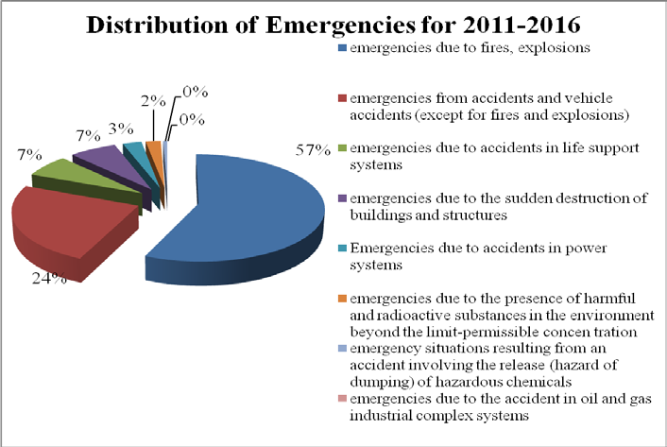
Fig. 1. Diagram of the distribution of emergencies of technogenic character by species during 2011–2016.

In order to assess the negative effects of each type of emergencies of technogenic character, the integral risks of these emergencies were calculated in accordance with the expression (3). The graphic interpretation of integral risks is shown in Fig. 2, with the highest levels corresponding to the integral risk of emergencies due to fires and

explosions,
2, 95 ⋅10−6
1/year, and the integral risk of emergencies due to accidents

and vehicle accidents (except for fires and explosions) 1, 98 ⋅10−6
1/year. The levels

of integral risks of other types of emergencies are less than one order (several orders of magnitude) of the above-mentioned risks.
It should be n oted that the analysis of only integral risks of emergencies of technogenic character for the estimation of the level of technogenic safety in the territory of Ukraine is not sufficiently informative as it does not take into account hazardous events that are not classified.

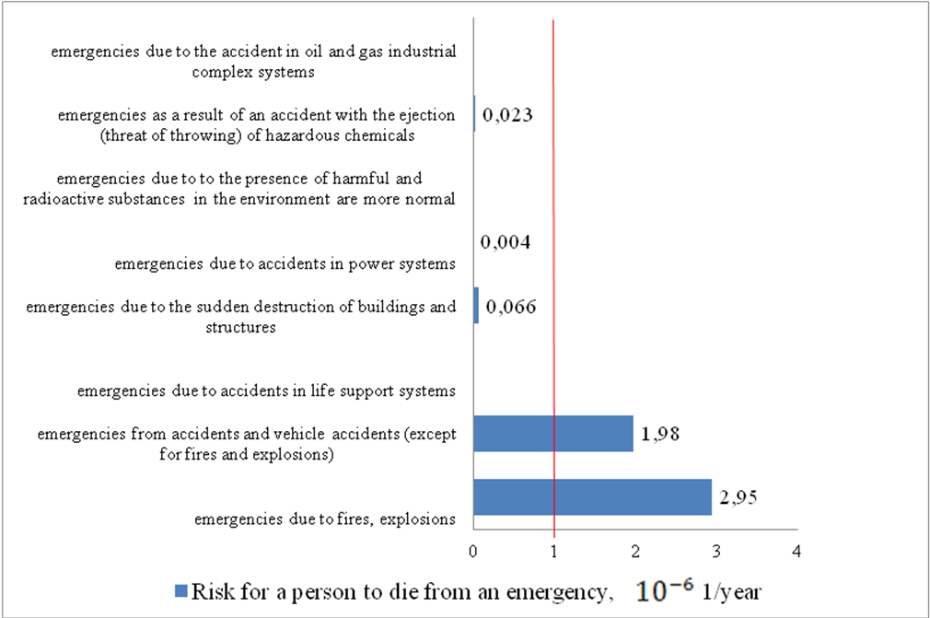
Fig. 2. Levels of integral risks of various types of emergencies of technogenic charac- ter.

The study of such dangerous events as fires and explosions and road accidents allowed to reveal the following:
- the average value of the number of fires and explosions in 2011–2016 is 69338 (Figure 3), with the average number of deaths due to these dangerous events is 2363 persons. For the same period, the average number of emergencies related to fires and explosions is 49, and the average number of deaths resulting from these emergencies is 127 people [10–15];
- the average number of accidents during 2011–2016 is 16,9991, and the average number of deaths due to these dangerous events is 4423 persons (Fig 4). For the same period, the average number of emergencies related to accidents and disasters in transport is 21, and the average number of deaths resulting from these emergencies is 85 people [10–15].
It is obvious that the number of emergencies associated with both fires and explosions and accidents and vehicle disasters is several times lower than the number of relevant dangerous events. A similar conclusion can be made regarding the death of people as a result of the above-mentioned emergencies and dangerous events. That

is, in order to objectively assess the level of technogenic safety on the territory of Ukraine, it should be investigated, in addition to emergency situations, as well as various types of dangerous events of technogenic character and their consequences. In this regard, consider the more detailed dynamics of the number of fires and explosions, road accidents, as well as their consequences during 2011–2016.
Figures 3 and 4 show the dynamics of the number of fires and explosions and the dynamics of traffic accidents during 2011–2016, respectively. From the graphs, it is clear that the dynamics of the number of fires and explosions tends to increase, and the regression line is decreasing for the traffic accidents. Nevertheless, if we compare the average number of events for the period under study, we see that the average number of fires and explosions is 69338, and the average number of accidents – 169991, which is 2.45 times more than the number of fires and explosions. Calculate the human risks of perishing from these dangerous events. For this it is necessary to consider statistical data [10–15] on the number of deaths from each type of hazardous event.
Dynamics of the number of fires
100000
80000
60000
40000
20000
0
2010 2011 2012 2013 2014 2015 2016 2017
Number of emergencies

Fig. 3. Dynamics of the number of fires and explosions during 2011–2016.
Dynamics of the number of traffic accidents
250000
200000
150000
100000
50000
0
2010 2011 2012 2013 2014 2015 2016 2017
Number of emergencies

Fig. 4. The dynamics of the number of traffic accidents during 2011–2016.

Figure 5 shows the dynamics of integral risk, which characterizes the consequences of fires and explosions. From the figure, there is a tendency to reduce the risk, but nevertheless, the value of the identified risk is still high enough and more than 5 times exceed acceptable limits [2].

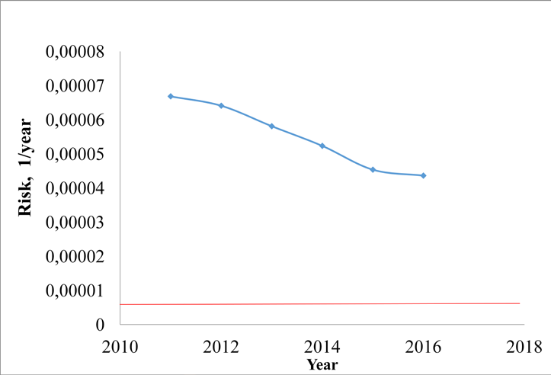
Fig. 5. A figure caption is always placed below the illustration. Short captions are centered, while long ones are justified. The macro button chooses the correct format automatically.

Fig. 6 shows the dynamics of integral risk
R3 , which characterizes the consequences

of road accidents. The level of integral risk R3
for traffic accidents as well as the

number of traffic accidents is reduced, but the risk of road deaths exceeds the norm by more than 10 times. Having analyzed Fig. 4 and 6, we see that the number of traffic accidents and integral risk R3 is directly related.
It can be concluded that the integral fire risk and integral risk of road accidents in 2011-2016 tend to decrease, but their level exceeds the maximum permissible. Thus, the level of integral fire risk is 5.5 times exceeding the maximum permissible (10−5 , 1/year), and the integral risk of road accidents – 10.3 times. If we compare the levels of the above integral risks in Ukraine with the maximum permissible level of risk in the developed countries of the world (1⋅10−6 , 1/year), the integral fire risk value exceeds this level by 55 times and the integral risk of road accidents is 100 times. That is, the given situation shows the presence of problems in the field of providing technogenic safety in our country.

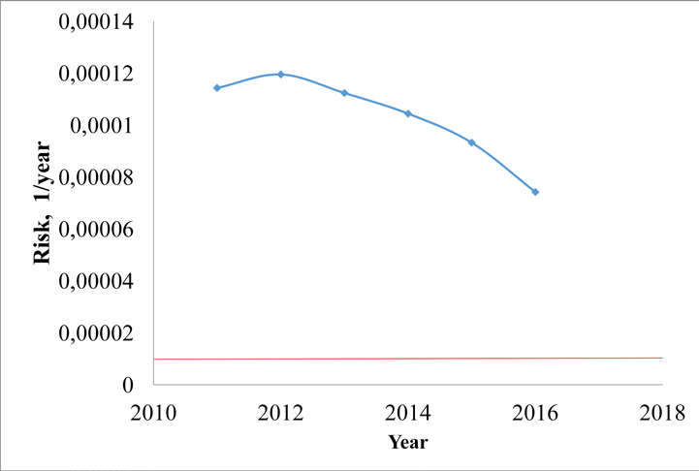
Fig. 6. Dynamics of Integral Risk of Road Accidents during 2011–2016, 1/year.

It can be concluded that the integral fire risk and integral risk of road accidents in 2011-2016 tend to decrease, but their level exceeds the maximum permissible. Thus, the level of integral fire risk is 5.5 times exceeding the maximum permissible (10−5 , 1/year), and the integral risk of road accidents – 10.3 times. If we compare the levels of the above integral risks in Ukraine with the maximum permissible level of risk in the developed countries of the world (1⋅10−6 , 1/year), the integral fire risk value exceeds this level by 55 times and the integral risk of road accidents is 100 times. That is, the given situation shows the presence of problems in the field of providing technogenic safety in our country.
To increase the level of technogenic safety, it is necessary to implement measures aimed at reducing the levels of relevant risks, ie to reduce the possible consequences of emergencies and dangerous events of technogenic character. But at the same time, it is necessary to identify the main factors that can influence the level of integral risks of emergencies and dangerous events. Since risk management is carried out to minimize the consequences of emergencies and hazardous events through the distribution of rescue units that play a major role in rescue operations (reduction of the consequences of emergencies and hazardous events), the factors of influence on integral risks should characterize the process of data retrieval subdivisions. It should also be noted that the task of minimizing the consequences of emergencies and dangerous events is the task of multi-criteria optimization, and the integral risks of emergencies and dangerous events of technogenic character are considered as criteria. The task of multicriteria optimization, as a rule, can be reduced to the task of one- criterion optimization using the following methods:

- the definition of the main criterion (target function), and for other criteria - the formation of restrictions;
- representation of the objective function as a convolution of partial criteria.
In this paper we will focus on the first method, since the integral risks of emergencies and dangerous events of technogenic character differ by more than an order of magnitude.
To determine the main criterion of the task of minimizing the consequences of emergencies and dangerous events, consider the distribution of the departures of the operational and rescue units, which is shown in Fig. 7.

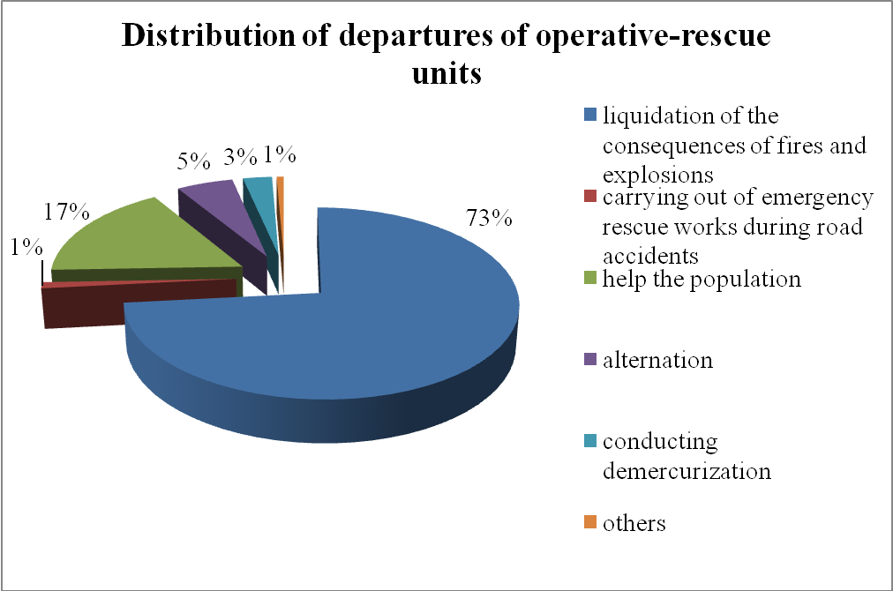
Fig. 7. Distribution of departures of operational and rescue units in Ukraine during 2011–2016.

It is obvious that 73% of the trips are to be used to eliminate the consequences of fires and explosions, 17% to help the population (for example, in the event of unfavorable domestic or non-standard situations), 5% for duty, 3% for demercuration, 1% for road accidents and other departures.
It should be noted that the bulk of fires and explosions occur in the residential sector, approximately 72% of the total number of events. Fig. 8 shows the risks for a person to die as a result of a fire and an explosion on various types of objects.
It is obvious that the risk for a person to die due to a fire and explosion in the residential sector is 5.27 times higher than the maximum permissible level.
The analysis of the distribution of departures of operational and rescue units allows to assert that as the main criterion in solving the problem of minimization of the consequences of emergencies, it is expedient to consider the integral fire risk, and

other integral risks of emergencies and hazardous events should be taken into account in the constraints.

Fig. 8. Risk for a person to die from a fire and an explosion on various types of objects, 10−5 1/year.

Thus, the analysis of risks characterizing the consequences of emergencies of technogenic character on the territory of Ukraine has been carried out. This made it possible to conclude that the highest levels have integrated risks of emergencies related to fires and explosions, as well as accidents and vehicle disasters. Comparison of the quantity and consequences of dangerous events and emergencies of technogenic character has made it possible to state the fact that for the objective assessment of the level of technogenic safety on the territory of Ukraine, it is necessary to take into account the specified dangerous events. It was determined that the levels of integral fire risk and integral risk of road accidents in the territory of Ukraine, respectively, are 5.5 and 10.3 times exceeding the maximum permissible level, which indicates the presence of problems in the field of technogenic safety in our country. To increase the level of technogenic safety, it is necessary to implement measures aimed at reducing the level of appropriate risks, that is, to reduce the possible consequences of emergencies and dangerous events of technogenic character. Since the task of minimizing the consequences of emergencies relates to the tasks of multicriteria optimization, in order to reduce it to the task of one-criterion optimization, the choice of the main criterion (integral fire risk) was justified, and other integral risks of emergencies and dangerous events should be taken into account in the constraints.

It was assumed that the risk
R3 depends on factors such as:
N fire
- the number

of fires recorded in the region;
M заг
- the number of deaths due to fires in the

region;
τ arrive
- the time of the fire and rescue units' follow-up to the place of

emergencies (fires);
liquidation.
τloc
- localization time of the fire;
τliq
- time of fire

A correlation matrix (Table 1) was constructed to determine the causal relationships between the investigated factors, which makes it possible to determine the relationship between the integral fire risk and the revealed factors. It is obvious that the coefficients 0.936, 0.895 and 0.779 show a close relationship between the

level of integral fire risk and factors τ arrive , τloc
and τliq . Thus, one of the levers

of the impact on the integral fire risk
R3 is the time of the fire and rescue units'

follow-up to the place of emergencies (fires) and the time of localization of the fire, which depend on the location and resources of the fire and rescue units.

Table 1. Correlation matrix of the main factors.

 | R3 | N fire | Mvictims | τ arrive | τloc | τliq
R3 | 1,000 | -0,832 | 1,000 | 0,836 | 0,895 | 0,779
N fire | -0,832 | 1,000 | -0,832 | -0,528 | -0,697 | -0,419
Mvictim | 1,000 | -0,832 | 1,000 | 0,836 | 0,895 | 0,779
τ arrive | 0,836 | -0,528 | 0,836 | 1,000 | 0,795 | 0,934
τloc | 0,895 | -0,697 | 0,895 | 0,789 | 1,000 | 0,714
τliq | 0,779 | -0,419 | 0,779 | 0,934 | 0,714 | 1,000

As a result of the correlation-regression analysis, the dependence of the integral fire risk R3 on the significant parameters was obtained:

R3 = (0, 203τ loc +0,117τ liq − 0,17 ⋅10−4 N fire + ε )⋅10−5

(4)

Standard error of estimation thus makes 0,13701⋅10−5 . Since the average value of the dependent variable is equal 5, 27 ⋅10−5 , the error is only 2.6 %, which is satisfactory.

It should be noted that in expression (4) the variable
N fire
has a negative

coefficient. This is due to the fact that, according to available statistical information, with an increase in the number of dangerous events (fires and explosions), there is a tendency to reduce the number of deaths, as evidenced by the Fig. 9.

Fig. 9. Dependence of the number of deaths from the number of fires and explosions.
2500

2000

1500
y = -0,0148x + 2735,9
1000

500

0
40000 45000 50000 55000 60000 65000 70000 75000
Number of fires and explosions
Number of dead, perons

Thus, the following problem arises. Let the area global coordinate system be given. The area
S0 in the form of a polygon in a
S0 has prohibited objects Lξ ,

ξ = 1,😐, L in which it is inadmissible to place fire and rescue units. It is necessary to

minimize the risk for a person to perish from a fire per unit time in the region
S0 by

determining the additional number of fire and rescue units
Pi ,
i = 1,😐, N
(these

areas are polygons with variable metric characteristics), with the following
restrictions:
- the minimum cross-sectional area for the operation of fire and rescue units;
- affiliation of areas of operation of the fire and rescue subdivisions of the region
S0 ;
- minimum area of intersection of areas of operation of fire and rescue units with areas of prohibition Lξ , ξ = 1,😐, L ;

- the presence of high-risk objects and potentially hazardous objects
Sd ,

d = 1,😐, D and the areas Md
of intersection of areas of operation of fire and rescue

units providing emergency response (fire) to the high-risk objects or potentially
hazardous objects according to the call number;

– time of arrival of fire and rescue units to the most remote point of departure
i = 1,😐, N , must not exceed the given T * ;
Pi ,

- placement of fire and rescue units is carried out taking into account the existing
Pq , q = 1,😐, Nq ;
- placement of fire and rescue units is carried out taking into account of the limited resources.

It should be noted that this task is relevant and complies with the Strategy of Reform of the State Service of Ukraine for Emergencies [3].
The mathematical model of risk management for a person to perish from a fire per unit time has the following form:
min R3 (N fire , Mvictims , τ arrive , τloc , τliq , u ) ; u = {mi ;vi } ; i = 1,😐, N ; (5)
u∈W

where W :
ω (mi , mj , vi , v j )→ min ; (6)

i = 1,😐, N ;
j = i + 1,😐, N ;

ω (mi , mcS
0 , vi , vcS0
)→ min ; (7)

i = 1,😐, N ; S0 cS0 = R ;
2
ω (mi , mξ , vi , vξ )→ min ; (8)
i = 1,😐, N ; ξ = 1,😐, L ;
Md
'
'
Sd ∈  Pk ; d = 1,😐, D ; Pk ∈{Pi } , i = 1,😐, N ; (9)

k =1

τ arrive (Pi ) ≤ T * ; i = 1,😐, N ; (10)
ω (mi , mq , vi , vq )→ min ; (11)
i = 1,😐, N ; q = 1,😐, Nq ;
Qres ( N ) ≤ Q* s . (12)
re

In the model (5)÷(12), the expression (5) is the target function of the task, while mi –

the metric characteristics of the objects Pi , i = 1,😐, N
(for example, the coordinates

of the vertices of the polygons in the local coordinate system), vi
- the parameters of

the location of objects Pi
(the position of the local system coordinate i of an object

in the global coordinate system); expression (6) – a condition for the minimum cross-

section of objects Pi
and
Pj ; expression (7) is the condition for the minimum

crossing of objects Pi
with the addition of the region
S0 to the Euclidean space;

expression R2 ; (8) – a condition for the minimum interconnection of objects Pi
with

areas of prohibition Lξ ,
ξ = 1,😐, L ;; expression (9) – the condition of the

membership of objects
Pi , which represent points in
S0 , the area of intersection of

objects P'
k
belonging to the set of objects Pi ; expression (10) – a condition regarding

the admissible time of arrival of fire and rescue units to the place of call; expression

  - – the condition of minimum interconnection of objects Pi
and
Pq ; expression

  - – the condition that the resources for the additional introduction of fire and
rescue units do not exceed the allocated Q* .
res
It should be noted that the constraints of the model (6)÷(8), (11) are represented by the co-coating function introduced by Yu. Stoyana and S. Yakovleva [6].
Under fire and rescue units we will understand the units of not only state fire protection, but also local and voluntary. Thus, a risk-based approach to determining of the parameters of the emergency response subsystem (fires) at the regional level is used.
Let's consider the features of the model (5)÷(12):
- the task of managing the risk for a person to perish from a fire per unit time refers to tasks of nonlinear programming;
- the domain of admissible solutions is determined, in the general case, by a system of nonlinear equality and inequalities and is limited and inconsistent;
- the total number of sets of equality and inequalities through which the

formalization of the limitations of the task is equal C 2
- N (L + N
+ 2) + D + 1 ;

N q
  - this task can be solved without taking into account the restriction (12);
  - if the existing fire-rescue units are not taken into account, then the model does not take into account the limitations (10).
Thus, a mathematical model for risk management for a person to perish from a fire per unit of time will further develop a well-founded method for solving the problem (5) ÷(12).

Conclusions

The work analyzes the emergencies of technogenic character and identifies the risks of various types of emergencies. It is determined that the level of integral fire risk is
5.5 times exceeding the maximum permissible (10−5 , 1/year). The correlation matrix for the investigated parameters is calculated and close relationships between the fire risk and the time of travel to the place of call, localization and liquidation of the emergency (fire) are established. The mathematical model of risk management for a person to die from a fire for a unit of time has been developed and its features have been investigated. Further research will be aimed at developing a method, algorithmic and software solution to the task.

References
- DSTU 3891:2013 (2014) Bezpeka u nadzvychainykh sytuatsiiakh. Terminy ta vyznachennia osnovnykh poniat. 34 s.
- Pro skhvalennia Kontseptsii upravlinnia ryzykamy vynyknennia nadzvychainykh sytuatsii tekhnohennoho ta pryrodnoho kharakteru. URL: http://zakon.rada.gov.ua/laws/show/37-2014-р.
- Pro skhvalennia Stratehii reformuvannia systemy Derzhavnoi sluzhby Ukrainy z nadzvychainykh sytuatsii. URL: http://zakon2.rada.gov.ua/laws/show/61-2017-
%D1%80.
- Kravtsiv SYa, Sobol OM, Maksimov AV (2016) The analysis of integral risks of the territory of Ukraine. Problems of Emergency Situations. Kharkiv : NUCDU. Vol. 23. pp. 53–60. URL: http://nuczu.edu.ua/sciencearchive/ProblemsOfEmergencies/vol23/Kravtsiv.pdf.
- Kravtsiv SYa, Sobol OM (2016) Analiz zakordonnoho dosvidu derzhavnoho rehuliuvannia rivnia pryiniatnoho ryzyku. Visnyk Natsionalnoho universytetu tsyvilnoho zakhystu Ukrainy. Seriia: Derzhavne upravlinnia. №. 2. S. 297–302. URL: http://nuczu.edu.ua/sciencearchive/PublicAdministration/vol5/Visnyk_NUCZU_ 41_2016_2(5).pdf.
- Kravtsiv SYa, Sоbоl OM (2016) Analiz integralnogo pozhezhnogo ryzyku na terytoriyi rajoniv Xarkivskoyi oblasti. Collection of scientific works of KNUAF. Kharkiv : KNUAF. Т. 4. №. 49, S. 177–179. URL: http://repositsc.nuczu.edu.ua/bitstream/123456789/2037/1/Visnyk_NUCZU_41_ 2016_2%285%29.pdf.
- Коmyak Va, Komyak Vl, Danilin A (2017) A study of ellipse packing in the high-dimensionality problems. Eastern-European Journal of Enterprise Technologies. Kharkiv, Vol. 1/4 (85), pp. 17–23.
- DK 019:2010 (2010) Natsionalnyi klasyfikator Ukrainy «Klasyfikator nadzvychainykh sytuatsii». URL: http://kharkivoda.gov.ua/content/documents/6/546/Attaches/20110211klassifikat or.pdf/.
- Brushlinskii NN ta dr. (2012) Osnovy teorii pozharnykh riskov i ee prilozheniia : monografіia. Мoskva : Akademiia GPS MChS Rossii, 192 s.
- Natsionalna dopovid Pro stan tekhnohennoi ta pryrodnoi bezpeky v Ukraini u 2011 rotsi. Rozdil 3. Zahrozy tekhnohennoho kharakteru ta zakhody shchodo minimizatsii yikh nehatyvnykh naslidkiv. URL: http://undicz.dsns.gov.ua/files/Національна%20доповідь/2011/3_2011.pdf.
- Natsionalna dopovid Pro stan tekhnohennoi ta pryrodnoi bezpeky v Ukrani u 2012 rotsi. Rozdil 3. Zahrozy tekhnohennoho kharakteru ta zakhody shchodo minimizatsii yikh nehatyvnykh naslidkiv. URL: http://undicz.dsns.gov.ua/files/Національна%20доповідь/2012/3_2012.pdf.
- Natsionalna dopovid Pro stan tekhnohennoi ta pryrodnoi bezpeky v Ukrani u 2013 rotsi. Rozdil 2. Zahrozy tekhnohennoho kharakteru ta zakhody shchodo minimizatsii yikh nehatyvnykh naslidkiv. URL: http://undicz.dsns.gov.ua/files/Національна%20доповідь/2013/2_2013.pdf.

- Natsionalna dopovid Pro stan tekhnohennoi ta pryrodnoi bezpeky v Ukrani u 2014. Hlava 1 Stan tekhnohennoi bezpeky. URL: http://undicz.dsns.gov.ua/files/Національна%20доповідь/2014/1_2014.pdf.
- Analitychnyi ohliad stanu tekhnohennoi ta pryrodnoi bezpeky v Ukraini za 2015 rik. Hlava 1. Stan tekhnohennoi bezpeky. URL: http://undicz.dsns.gov.ua/files/Аналітичний%20огляд/Glava_1.pdf.
- Analitychnyi ohliad stanu tekhnohennoi ta pryrodnoi bezpeky v Ukraini za 2016 rik. Hlava 1. Stan tekhnohennoi ta pryrodnoi bezpeky. URL: http://undicz.dsns.gov.ua/files/Національна%20доповідь/2016/3_I_СТАН_ТЕ ХНОГЕННОI_ТА_ПРИРОДНОI_БЕЗПЕКИ_home.pdf.

