A.M. Kudin, Dr.Sci., senior researcher, docent; V.G. Borisenko, PhD, associate professor, docent; L.A. Andryushchenko, PhD, senior researcher; M.M. Goroneskul, aspirant, teacher; National University for Civil Defence of Ukraine;
W. Brzozowska, Institute of Marine and Environmental Sciences, University of Szczecin, Poland; I. Wojtczak, E. Olewnik-Kruszkowska; M. Sprynskyy, Nicolaus Copernicus University, Toruń, Poland

Mechanism OF Diatomaceous Biosilica INFLUENCE ON THE FIRE RESISTANCE OF SILICON PROTECTIVE COATING

It is well known that textiles are highly combustible materials and therefore are a risk factor in terms of fire safety. For thermal and fire protection of fabrics, as well as to prevent the negative effects of oxygen, ozone, water and UV light, coatings based on silicone polymers [1] are widely used. To obtain fire-resistant coatings, flame retardants are used, which differ in the mechanism of action [2]. Firstly, these are flame retardants (halogen-containing additives) in the gas phase, which are almost never used for environmental reasons. Secondly, coking catalysts, i.e. substances that promote the formation of coke residue at the "polymer-flame" interface. Thirdly, substances that reduce the surface temperature of the material, such as aluminum trihydrate or magnesium hydroxide. One more mechanism can be added to the listed mechanisms, namely, the barriers formation in polymer volume. This effect is typical for lamellar or flake fillers, such as mica, talc, montmorillonite, etc. The presence of barriers slows down both the diffusion of combustible gases from the bulk of the polymer into the gas phase and the penetration of oxygen into the polymer, see the scheme in Fig. 1 (a).
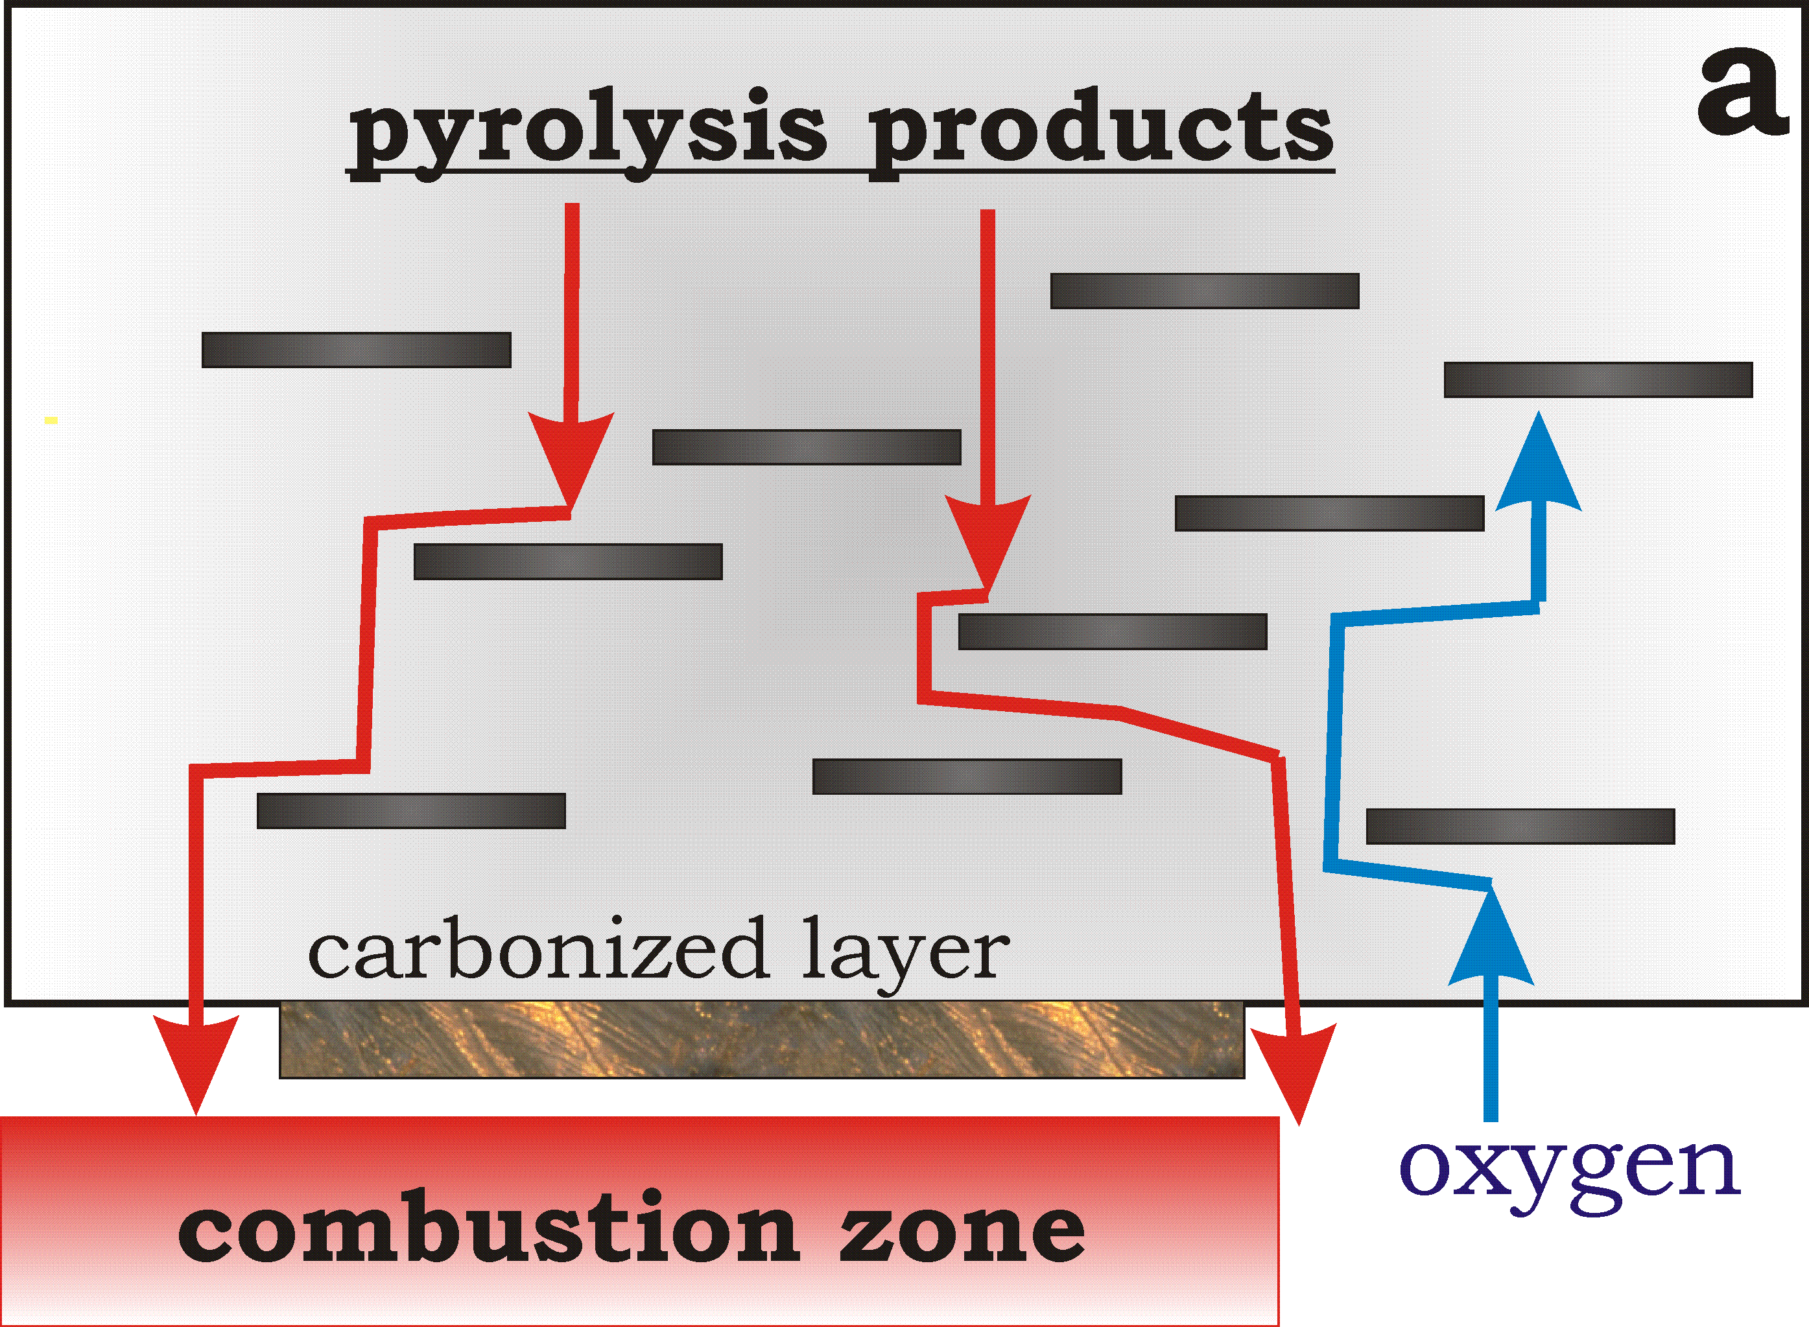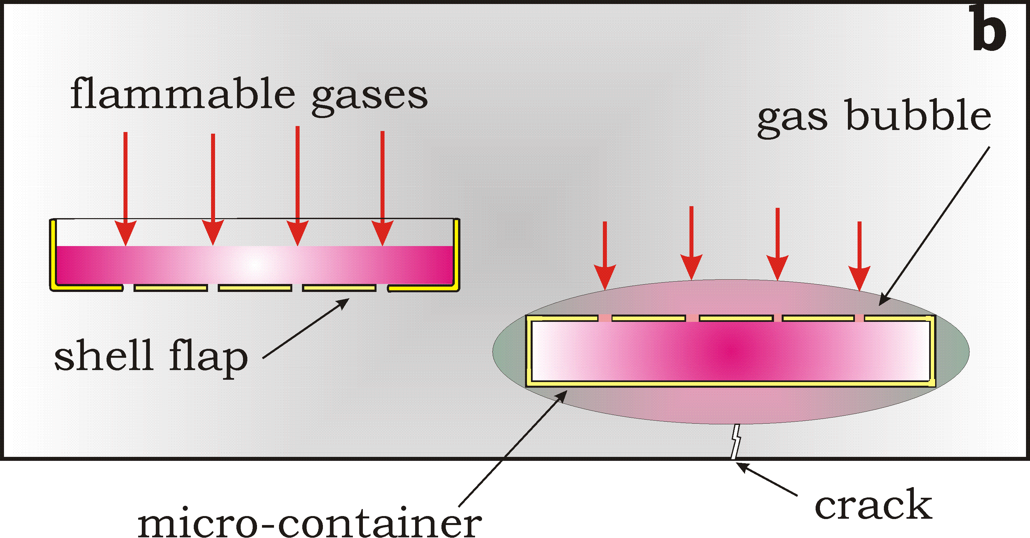
Fig. 1. Scheme of the barrier (a) and the proposed mechanism (b) of flame retardation
It was recently shown [3] that introduction of an unusual filler as diatomaceous biosilica to the silicone elastomer Sylgard-184 significantly improves the heat resistance of the protective film. Thus, the temperature corresponding to a 30% weight loss increases by almost 150°C for diatomaceous biosilica-filled silicone rubber compared to a composition without filler or filled with talc microblades, as it clearly seen in Fig. 2. This figure represents TGA data concerning the mass loss for composition on a base of elastomer Sylgard-184 without filler (curve 1) and for coating with 3% of diatomaceous biosilica (curve 2). It should be noted that difference between two curves is very significant for temperatures above 500°C. This means that combustible decomposition products of the polymer are not released into the gas phase.
Particles of diatomaceous biosilica (shells of algae) are micro-containers with a diameter of about 4 μm. Individual shell flaps, which are similar in shape to a Petri dish, are perforated with an ordered system of pores 150-200 nm in diameter [3]. Diatomaceous biosilica was fabricated by the cultivation of the selected diatom species under laboratory conditions. A detailed description of the method is given in the article [4]. Diatom cells were collected by filtration via Millipore 0.45 μm filters using a vacuum pump. The diatom biosilica was isolated from washed diatom cells using hydrogen peroxide (30% of the H₂O₂) to digest organic matter at 80°C for 4 h, and hydrochloric acid (37% of the HCl) to dissolve calcium carbonates at the end of the hot hydrogen peroxide oxidation process. The obtained diatom biosilica was washed with distilled water and dried at 120°C in air.
According to our data the protect coating on a base of elastomer Sylgard-184 with a filler of diatomaceous biosilica increases also the fire resistance of the fabric. The tests on fire retardant were carried out in accordance with accepted requirements (DSTU 4155-2003). The results of tests are shown in Fig. 3. As it seen from the data of Fig. 3b the application of the coating "Sylgard-184 + diatomaceous biosilica" on aramid fabric leads to the fact that the fabric retains its integrity after 6 minutes of exposure to an open flame. Moreover, the fabric partially retains elasticity even at the site of exposure to an open flame, i.e. in the region of maximum temperature. At the same time, the sample without filler burns out after 3 minutes, see Fig.3a. The term "burns through" here means the appearance of cracks and the subsequent destruction (shedding of the sample) of the tissue in the area of exposure to an open flame.

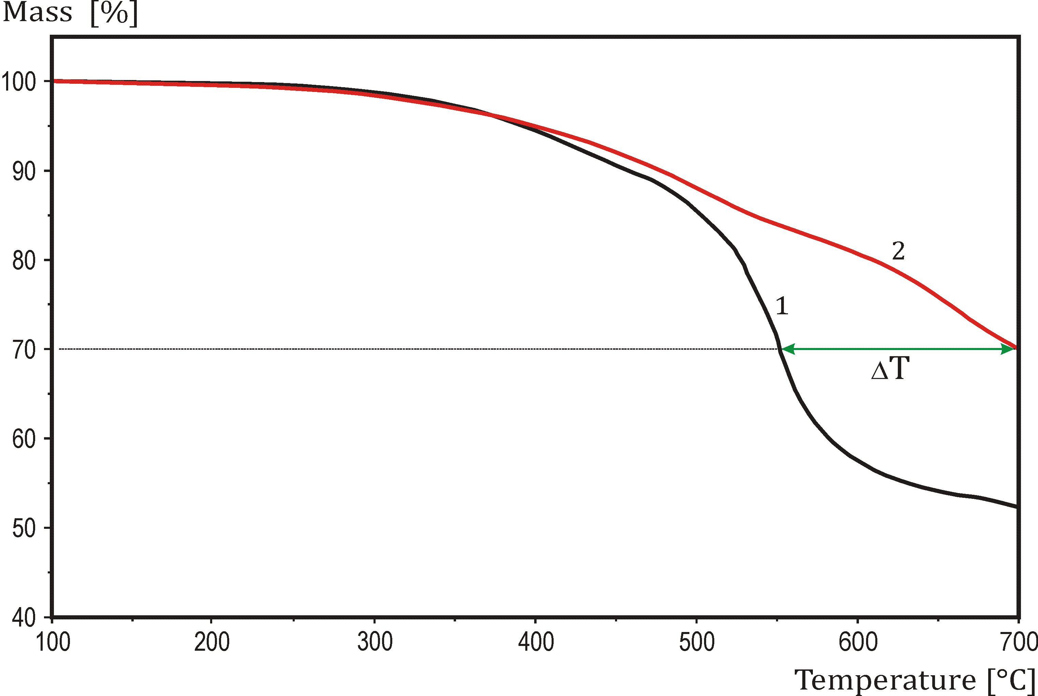 | backside240 s  a8  b  front side 360 s
Fig. 2. TGA data for composition on a base of elastomer Sylgard-184 without filler (1) and Sylgard-184 with 3% of diatomaceous biosilica (2) | Fig. 3. Photo of samples after tests. Sylgard-184 coating without filler (a) and proposed composition (b)

A known barrier mechanism for increasing the fire resistance of polymer has been considered above. This mechanism is characteristic of fillers in the form of plates or scales. When biosilica is used as a filler, its particle is similar to a Petri dish; such particles can serve not only as a barrier, but also as a concentrator of decomposition products. Hydrogen, methane, and ethane are the most flammable among the volatile decomposition products of the silicon matrix. We believe that namely these gases can be accumulated in the closed (semi-closed) volume of the filler particles. If the average distance between the particles is less than the thickness of the coating, then the primary sink for combustible gases will be not the film surface, but the micro-containers of a filler. With prolonged heating, a gas bubble may form in this place. The formation of gas bubbles slows down the process of mass loss and shifts the slope of curve 1 to the right in the Fig. 2. So, the filler of diatomaceous biosilica may be play a role of a flame retardant. This assumption needs careful verification.
Usually, the coating performs several purposes, in addition to the function of thermal and fire protection of the substrate material, it is desirable that the coating is hydrophobic [1], wear-resistant, reliably protects the fabric from atmospheric factors [5], has high adhesion to the substrate, contributes to the extension of the service life [1, 5]. It is known that the polymer base of Sylgard-184 is able to provide solutions for some of these purposes [6-8] like waterproof coating [7], adhesion promoter and even luminescence layer [8]. To implement the last two purposes, it is necessary to dope the composition with a phosphor, such as coumarin, or an adhesive, such as halloysite or microwollastonite.
From considered results it can be concluded that protective coating on a base of elastomer Sylgard-184 with a filler of diatomaceous biosilica improves significantly the heat resistance of the protective film as well as increases also the fire resistance of the fabric. It has been proposed a possible explanation of the effect and mechanism of it realization. According to proposed mechanism the filler serves as a natural sink for combustible decomposition products and prevent the oxygen diffusion into polymer and hinder the transport of gaseous products of pyrolysis to the gas phase.

References

- Tarakhno, E.V.; Andryushchenko, L.A.; Kudin, A.M.; Trefilova, L.N. (2014) Application of organosilicon polymers for flameproof clothing. Problems of fire safety, 36, 243-258.
- Fire Retardant Polymers and Composite Materials (under D.-Y. Wang Ed.) // Woodhead Publishing, 2016, 342 p.
- Olewnik-Kruszkowska, E.; Brzozowska, W.; Adamczyk, A.; Gierszewska, M.; Wojtczak, I.; and Sprynskyy, M. (2020) Effect of Diatomaceous Biosilica and Talc on the Properties of Dielectric Elastomer Based Composites // Energies, 13. P. 5828-5845.
- Sprynskyy, M.; Pomastowski, P.; Hornowska, M.; Król, A.; Rafinska, K.; Buszewski, B. (2017) Naturally organic functionalized 3D biosilica from diatom microalgae. Mater. Des., 132, 22–29. doi.org/10.1016/j.matdes.2017.06.044
- Andryushchenko, L.A.; Borisenko, V.G.; Goroneskul M.M.; Кudin, A.M. (2021) Evacuation sign with luminescent coating on a base of elastomer Sylgard-184 // Emergency Situations: prevention and elimination, 5(2), 5-18.
- Skorodumova, O.; Tarakhno, O.; Chebotaryova, O.; Hapon, Y.; Emen, F.M. (2020) Formation of Fire Retardant Properties in Elastic Silica Coatings for Textile Materials // Problems of Emergency Situations: Materials and Technologies, 25−31.
- Shpilinskaya, A.L.; Кudin, A.M; Andryushchenko, L.A.; Didenko, A.V.; Zelenska, O.V (2020) A protective hydrophobic coating for CsI(Tl) crystals // Instr. Experimental Technique, 63(1), 30-33.
- Patent UA 147605 A62B 3/00. Technique for luminescence coating application / M.M. Goroneskul, L.A. Andryushchenko, A.M. Кudin, Yu.V. Lutsenko, V.G. Borisenko, I.A. Barabash. No u202007407; date of priority 20.11.2020; date of publ. 26.05.2021; bull. No 21.

О.М. Кудін, д.т.н., с.н.с., доцент кафедри; В.Г. Борисенко, к.ф.-м.н, доцент, доцент кафедри; Л.А. Андрющенко, к.т.н., с.н.с.; М.М. Горонескуль, аспірант, викладач кафедри; Національний університет цивільного захисту України
W. Brzozowska, Institute of Marine and Environmental Sciences, University of Szczecin, Poland; I. Wojtczak, E. Olewnik-Kruszkowska; M. Sprynskyy, Nicolaus Copernicus University, Toruń, Poland

МЕХАНІЗМ ВПлИву биокремнезему на вогнестійкість силіконових захисних покриттів

Запропоновано новий механізм підвищення термо- та вогнестійкості силіконових композицій для захисних покриттів. Показано, що покриття на основі еластомеру Sylgard-184, у який введено біокремнезем в якості наповнювачу, забезпечує як термостійкість, так і вогнестійкість тканинної підкладки, якщо вміст наповнювача складає 1-3% мас. На основі запропонованого механізму дано пояснення процесів, що призводять до уповільнення розкладання матриці.

