**EXPERIMENTAL RESULTS**

Тable 3.1

The results of the calculation of excess pressure inside the protective device

|  |  |  |  |  |  |  |  |  |  |  |  |
| --- | --- | --- | --- | --- | --- | --- | --- | --- | --- | --- | --- |
| m, g | 20 | 30 | 40 | 50 | 60 | 70 | 80 | 90 | 100 | 110 | 120 |
| $Δp_{calcul},$ kPa | 1,565 | 2,093 | 2,6 | 3,087 | 5,566 | 4,047 | 4,52 | 4,988 | 5,44 | 5,902 | 6,36 |

Тable 3.2

Estimated values of the reduced indicator of excess pressure inside the protective device and the limits of the confidence interval

|  |  |  |  |  |  |  |  |  |  |  |  |
| --- | --- | --- | --- | --- | --- | --- | --- | --- | --- | --- | --- |
| m, г | 20 | 30 | 40 | 50 | 60 | 70 | 80 | 90 | 100 | 110 | 120 |
| $$\frac{Δp_{calcul}}{Δp_{min}}$$ | 1 | 1,34 | 1,66 | 1,97 | 2,27 | 2,58 | 2,88 | 3,18 | 3,47 | 3,77 | 4,06 |
| α=-0,05 | 0,95 | 1,28 | 1,49 | 1,77 | 2,16 | 2,45 | 2,73 | 3,02 | 3,29 | 3,58 | 3,86 |
| α=+0,05 | 1,05 | 1,47 | 1,83 | 2,06 | 2,38 | 2,7 | 3,02 | 3,34 | 3,64 | 3,95 | 4.26 |

Тable 3.3

Scheme of explosions inside a protective device

|  |  |  |  |  |  |  |  |  |  |  |  |  |  |  |  |
| --- | --- | --- | --- | --- | --- | --- | --- | --- | --- | --- | --- | --- | --- | --- | --- |
| Mass of TNT equivalent, g | Blasting scheme | | | | | | | | | | | | | | |
| 50 | 1 | 2 |  |  |  |  |  |  |  |  |  |  |  |  |  |
| 60 |  |  |  | 4 | 5 | 6 | 7 | 8 | 9 | 10 |  |  |  |  |  |
| 70 |  |  |  |  |  |  |  |  |  |  |  | 12 | 13 |  |  |
| 100 |  |  | 3 |  |  |  |  |  |  |  | 11 |  |  | 14 |  |
| 120 |  |  |  |  |  |  |  |  |  |  |  |  |  |  | 15 |
|  |  |  |  |  |  |  |  |  |  |  |  |  |  |  |  |
| Actual mass of additional load, kg | 250 | 250 | 750 | 350 | 350 | 350 | 350 | 350 | 350 | 350 | 750 | 450 | 450 | 750 | 850 |

Тable 3.4

Experimental results of determining the overpressure inside the protective device under load

|  |  |  |  |  |  |  |  |
| --- | --- | --- | --- | --- | --- | --- | --- |
| proof № | 1 | 2 | 3 | 4 | 5 | 6 | 7 |
| kPa | 3,10 | 3,06 | 5,52 | 3,62 | 3,45 | 3,4 | 3,73 |
|  | 1,98 | 1,95 | 3,53 | 2,31 | 2,2 | 2,38 | 2,37 |
| proof № | 8 | 9 | 10 | 11 | 12 | 13 | 14 | 15 |
| kPa | 3,45 | 3,72 | 3,51 | 5,61 | 4,15 | 4,21 | 5,65 | 6,1 |
|  | 2,17 | 2,24 | 2,27 | 3,58 | 2,65 | 2,69 | 3,61 | 3,89 |

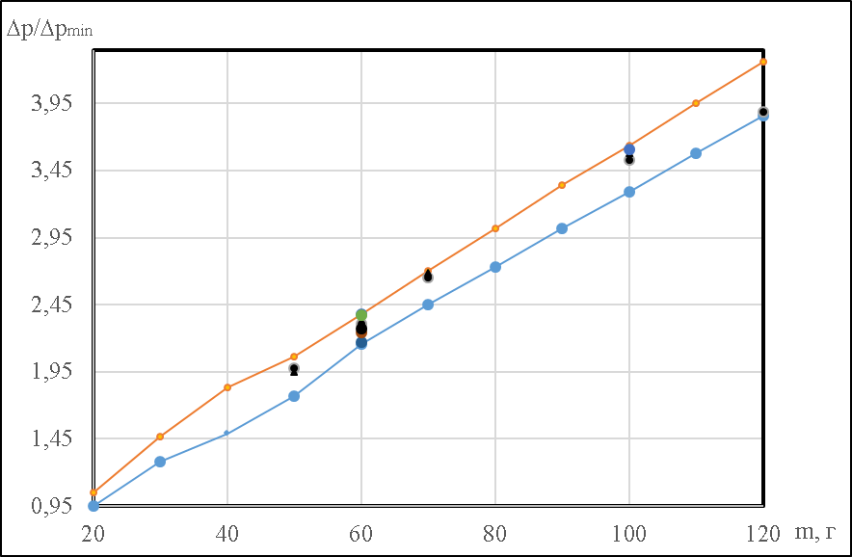

Рисунок 3.2. Verification of the conclusion experimental results in the interval ± 5% in relation to the calculated indicators.

Тable 3.5

The results of wearing the Modul - 4C bulletproof vest in the summer

|  |  |  |  |  |  |  |  |  |  |  |
| --- | --- | --- | --- | --- | --- | --- | --- | --- | --- | --- |
| n | 1 | 2 | 3 | 4 | 5 | 6 | 7 | 8 | 9 | 10 |
| , c | 44,37 | 39,73 | 34,47 | 38,92 | 28,44 | 33,3 | 25,42 | 22,32 | 32,22 | 26,64 |
|  | 123,37 | 64,11 | 46,06 | 46,06 | 24,87 | 23,98 | 7,60 | 5,23 | 1,58 | 1,46 |
| n | 11 | 12 | 13 | 14 | 15 | 16 | 17 | 18 | 19 | 20 |
| , c | 28,53 | 35,95 | 31,14 | 26,64 | 32,67 | 30,67 | 42,73 | 43,65 | 32,17 | 38,56 |
|  | 0,57 | 0,02 | 1,09 | 6,37 | 26,35 | 30,17 | 39,73 | 86,55 | 104,51 | 119,75 |
|  |  |  |  |  |  |  |  |  |  |  |
| , c | 33,43 | | | | | | | | | |
| , c | 6,32 | | | | | | | | | |
|  | 759,42 | | | | | | | | | |

Тable 3.8

Generalized results of experimental studies

|  |  |  |
| --- | --- | --- |
| Parameter | Modul - 4C (summer) | Modul - 4C (winter) |
| 1 | 2 | 3 |
| Carrying a protective device | | |
| m/s | 0,299 | 0,116 |
| , m/s | 0,021 | 0,009 |
| Transferring a unit of additional load | | |
| , m/s | 0,693 | 0,326 |
| , m/s | 0,100 | 0,060 |
| Movement without load in personal protective equipment of a pyrotechnician | | |
| , m/s | 1,020 | 0,776 |
| , m/s | 0,158 | 0,207 |
| Installation of a protective device on top of a small explosive object | | |
| , s | 35,39 | 59,83 |
| , s | 6,58 | 10,23 |
| Arrangement of the additional load unit in accordance with the developed method | | |
| , s | 14,63 | 40,62 |
| , s | 2,17 | 3,04 |
| Arrangement of protective embankment with six units of additional load | | |
| , с | 40,81 | 51,14 |
| , с | 5,11 | 5,16 |

Тable 3.9

Comparison of performance indicators of typical operations in Modul-4C body armor in summer and winter

|  |  |  |  |  |  |  |
| --- | --- | --- | --- | --- | --- | --- |
| A typical operation |  |  |  |  | $$t_{observ}$$ | $$t_{observ} \\ (α=0,05)$$ |
| 1 | 2 | 3 | 4 | 5 | 6 | 7 |
| Wearing personal protective equipment | 1,67 | 2,3 | 2,31 | 46 | 6,17 | 2,01 |
| Carrying a protective device | 0,46 | 2,3 | 2,31 | 46 | 8,96 | 2,01 |
| Transferring a unit of additional load | 1,02 | 2,3 | 2,31 | 46 | 6,57 | 2,01 |
| Movement of personnel in personal protective equipment | 0,96 | 2,3 | 2,31 | 46 | 4,23 | 2,01 |
| nstallation of a protective device on top of a small explosive object | 0,56 | 2,3 | 2,31 | 46 | 8,11 | 2,01 |
| Arrangement of an additional load unit | 1,72 | 2,3 | 2,31 | 46 | 5,95 | 2,01 |
| Arrangement of additional embankment | 1,68 | 2,3 | 2,31 | 46 | 7,57 | 2,01 |

Тable 4.1

pyrotechnicians for putting on personal protective equipment of a sapper

|  |  |  |  |  |  |  |
| --- | --- | --- | --- | --- | --- | --- |
|  | 4С  (summer) | 4С  (winter) | БЖ  (summer) | БЖ  (winter) | БЖЗТ-71  (summer) | БЖЗТ -71  (winter) |
| Estimated standard assessment | | | | | | |
| «5» | 25,33 | 37,22 | 58,15 | 62,07 | 33,37 | 81,13 |
| «4» | 33,43 | 47,68 | 84,18 | 92,57 | 47,71 | 101,56 |
| «3» | 41,53 | 58,14 | 110,21 | 123,07 | 62,05 | 121,99 |
| The proposed assessment of the norm | | | | | | |
| «5» | 25 | 37 | 60 | 60 | 35 | 80 |
| «4» | 35 | 47 | 85 | 90 | 45 | 100 |
| «3» | 40 | 57 | 110 | 120 | 60 | 120 |

Тable 4.2

Determination of standards for assessing the level of preparedness of pyrotechnicians for the use of the developed protective device in the Modul-4C bulletproof vest

|  |  |  |  |  |  |  |
| --- | --- | --- | --- | --- | --- | --- |
| valuation of the norm | «5» | | «4» | | «3» | |
| Season | summer | winter | summer | winter | summer | winter |
| 1 | 2 | 3 | 4 | 5 | 6 | 7 |
| nstallation of a protective device | | | | | | |
| Estimated valuation | 27,16 | 47,05 | 35,39 | 59,83 | 43,62 | 72,61 |
| Suggested valuation | 27 | 47 | 35 | 60 | 43 | 73 |
| Upgrading the element of the additional attachment with a weight of 60 kg | | | | | | |
| Estimated valuation | 11,93 | 36,83 | 14,63 | 40,62 | 17,33 | 44,41 |
| Suggested valuation | 12 | 37 | 15 | 40 | 18 | 43 |
| mprovement of the bunding with eight elements of the supplementary bunding with a weight of 60 kg | | | | | | |
| Estimated valuation | 34,43 | 44,71 | 40,81 | 51,14 | 47,19 | 57,57 |
| Suggested valuation | 34 | 45 | 41 | 51 | 48 | 57 |