UDC 614.8

N. M. Lysak, Postgraduate, Teacher of the department
O. B. Skorodumova, Doctor of Technical Sciences, Professor,
A. A. Chernukha, Ph.D., Associate Professor,
A.Y. Sharshanov, Doctor of Technical Sciences, Associate Professor,
Y.M. Goncharenko, PhD, Senior Lecturer of the Department
S.M. Shcherbak, PhD, Associate Professor

National University of Civil Defense of Ukraine, Cherkasy, Ukraine

SILICOPHOSPHATE FIREPROOF COMPOSITION FOR BUILDING FINISHING MATERIALS
The composition of silicophosphate composition based on liquid glass for fire protection of building finishing materials has been developed. The compositions were prepared by mixing aqueous solutions of liquid glass and acetic acid with the addition of phosphate buffer solutions with a pH of 6–8. The phase composition of the experimental compositions was investigated by infrared spectroscopy and the formation of Si–O–P bonds was established, which indicates the incorporation of phosphate ions into the siloxane framework of polysilicic acid gels. It was established that the polycondensation mechanism is influenced by the pH value of the phosphate buffer solution, as well as its content. The use of a buffer solution with a pH of 6 leads to the initialization of mainly net polycondensation in liquid glass sols. Increasing the pH to 7–8 ensures linear polycondensation of polysilicic acid, which increases the homogeneity of the gel coating, provides elasticity, and increases its fire-retardant effect. Conducted fire tests showed that the best fire-resistant properties have systems with a buffer solution content of 20-25 % with a pH of 7, which provide maximum resistance to fire and minimal loss of mass of samples during exposure to high temperatures. For such compositions, the 1st group of flame retardant efficiency is established, and the treatment of wood samples with them allows the material to be transferred to the "high-flammability" group. Extruded polystyrene samples covered with the developed compositions do not burn, the absence of burning drops is noted. The obtained results emphasize the prospects for the further development of such systems for the protection of building materials.
Keywords: silica, fire-resistant coatings, phosphate buffers, building materials, heat resistance, fire resistance, wood, expanded polystyrene.

1. Introduction
Despite the development of technologies and the constant improvement of safety measures, fires remain one of the most critical threats to human life and health. Public and residential buildings, where finishing and insulating building materials are used, are especially vulnerable. Among them, wood and extruded polystyrene foam have significant consumer demand, the fire safety of which, due to the high level of flammability, requires a careful approach to preventive measures.
A very effective passive fire protection mode is aimed at ensuring the ability of structures to resist fire for as long as possible and increasing the time for evacuation of people and the arrival of fire brigades. The priority direction of this type of protection is the use of fire-retardant coatings and technologies that reduce the flammability of combustible materials.
Silica-based coatings have proven themselves as an effective fire protection agent, which, due to their ability to form a protective layer when heated, reduce the risk of ignition and slow down the process of fire spread. In addition, silica-containing coatings provide additional mechanical strength of materials, stably retain their fire-retardant properties for a long time and are environmentally safe.
It is known that modification often plays a decisive role in improving the properties of materials or systems. By changing certain parameters, structure or composition, it is possible to achieve optimal characteristics, such as increased resistance, strength, stability or functionality. To increase the fire-retardant efficiency of silica-containing coatings, it is advisable to add special components that would contribute to the formation of compositions that can withstand higher temperatures and form a more stable protective layer. A good option for such modifying additives can be phosphorus-containing flame retardants, which will be a prerequisite for the formation of heat-resistant silico-phosphate bonds. The number of such compounds is quite large, which allows you to choose a component whose properties would best meet the given conditions. On the other hand, the task of choosing is not simple, since it is necessary to take into account a number of factors on which the effectiveness, safety and cost-effectiveness of the fire-retardant coating depend.
Thus, it is relevant to search for the optimal composition of the composition based on silicon and phosphorus compounds, which will allow combining the advantages of both elements for effective fire protection of building materials.

2. Analysis of literary data and formulation of the problem
The use of phosphorus-containing flame retardants as effective means for increasing the fire resistance of materials is widely studied in the scientific literature. Such substances are becoming widespread as an environmentally safe alternative to toxic halogen flame retardants. Another advantage of their use in the field of fire safety is the ability to exhibit fire-fighting properties in both the gas and condensed phases during the combustion process. This characteristic makes phosphorus-containing substances universal and effective fire-retardant agents. In the condensed phase, phosphorus compounds contribute to the formation of a protective carbon layer that prevents the access of oxygen and the spread of fire. In the gas phase, these flame retardants decompose under the influence of high temperatures with the release of phosphorus-containing groups that are able to capture active radicals H• and HO•, catalyzing dehydration processes [1].
Recently, organic phosphorus-containing substances have been considered promising flame retardants. The use of 9,10-dihydro-9-oxa-10-phosphaphenanthrene-10-oxide (DOPO) and its derivatives has attracted particular attention. In particular, in [2] it was shown that these flame retardants are able to trap oxygen radicals, acting as flame inhibitors and slowing down the transfer of heat to the polymer matrix. There are also a number of studies devoted to the study of the flame retardant behavior of systems created on the basis of combinations of DOPO and nitrogen-containing compounds. The authors of [3], for example, used a phosphorus-nitrogen flame retardant (CN-DOPO) by adding carbon nitride. The synergistic flame retardant mechanism of the resulting composite was confirmed by the increase in the limiting oxygen index and the formation of a dense protective carbon layer. High fire retardant performance was also obtained for a composition based on DOPO and melamine [4], but all of these flame retardants decompose into toxic components during operation that are harmful to the environment.
A separate group of organic phosphorus-containing flame retardants are phosphoric acid esters, for example, tris(2-butoxyethyl)phosphate (TBOEP) [5], tris(3,5-xylenyl)phosphate (TXP) or trimethylphosphate (TMP) [6]. Despite the excellent fire-fighting ability of these compounds, they are usually not chemically bound to the polymer matrix and can be released into the environment through evaporation, leaching, and mechanical friction, and worsen the ecological situation.
The results of the above works [2-6] are of great theoretical and practical importance, but the safety of organic phosphorus-containing compounds for the environment and human health is questionable. First of all, these substances are potential pollutants of aquatic ecosystems. The work [7] provides data confirming the ability of organophosphorus compounds to bioaccumulate in living organisms directly or, spreading over time through the trophic levels of the food chain. The results of some studies even indicate the negative impact of these flame retardants on molecular processes in cells, in particular on gene transcription, protein synthesis and energy metabolism [8].
Inorganic phosphorus-containing flame retardants are considered to be much more environmentally friendly than their organic counterparts, as they are not characterized by the release of toxic products during thermal decomposition. Numerous studies have focused on studying the flame retardant properties of compositions based on ammonium phosphates. Despite the relevance and value of these studies, it should be taken into account that inorganic flame retardants may be less effective at low concentrations, i.e., to achieve a high level of fire protection, a larger amount of additive may be required compared to organic phosphorus-containing compounds. In addition, some inorganic flame retardants are hygroscopic, which may lead to a decrease in their effectiveness or deterioration of properties during operation in conditions of high humidity.
The disadvantages of individual flame retardants can be minimized by using combined systems. There are a number of works devoted to the study of the synergistic flame retardant action of silicon and phosphorus compounds [9]. The results of the studies confirm the improvement of the fire-retardant properties of such compositions. In particular, silicon can improve the stability and structural integrity of the carbonized layer, the formation of which is facilitated by phosphorus-containing substances.
Such synergism of the two elements is the basis for ensuring more reliable protection of polymeric materials from thermal destruction in the event of a fire. In addition, it is known about the ability of phosphate groups to be incorporated into the siloxane framework, which increases its resistance to adverse climatic factors. Previously conducted studies focused on studying the effect of orthophosphate acid on the properties of silica-containing fire-retardant coatings [10]. The survivability indicators of the sols were satisfactory for high-quality application of the compositions to the surface of the materials. It was also previously established that buffer systems play a key role in obtaining high-fluidity sols [11]. In view of this, it would be advisable to consider phosphate buffer solutions as modifying additives in the composition of silica-containing compositions and to evaluate the fire-retardant efficiency of coatings based on them.

3. Purpose and objectives of the study
The purpose of the work is to study the influence of phosphate buffer solutions on the formation of the structure and fire-retardant properties of SiO₂-based coatings.
To achieve the set goal, it was necessary to perform the following tasks:
– to study the rheological properties of silicic acid sols modified with phosphate buffer solutions and the gelation processes in them;
– to evaluate the effectiveness of the fire-retardant silicophosphate coating by conducting fire tests on wood samples and extruded polystyrene foam.

4. Materials and research methods
The object of research is the fire protection of wooden and polystyrene foam finishing materials.
The subject of research is the processes of transformation of fire-retardant coatings during the action of fire.
The main hypothesis of the research is the possibility of embedding phosphate ions into the siloxane framework of the fire-retardant composition, which leads to an increase in the fire resistance of silica coatings.
Solutions of liquid glass and acetic acid were mixed using a magnetic stirrer. The obtained silicic acid sols were modified with a phosphate buffer solution prepared on the basis of sodium salts. The pH of the buffer solution (6, 7, 8) and its content (15, 20, 25 %) were varied.
Heat treatment of silica gels was carried out at 800 °C in an oxidizing environment (air), maintaining at a maximum temperature of 2 h (temperature rise rate 4–5 °C/min).
Wood samples (9x6x3 cm) were pre-dried in a drying oven at 100 °C to constant weight. Samples of extruded polystyrene foam brand XPS with a size of 5x5x3 cm were used. The resulting gel compositions were applied to the surface of the experimental samples by the bath method. The application of 2–3 layers of coating was carried out after drying the previous layer at 80 °C in a drying oven. Additionally, a 20 % aqueous solution of diammonium hydrogen phosphate was sprayed onto the surface of the dried samples and also dried.
The change in the optical density of the sols over time was determined using a KFK-2 photocolorimeter using a cuvette with l = 5 cm at a wavelength of 490 nm. Distilled water was taken as a reference solution.
Infrared absorption spectra of raw and heat-treated gels were recorded on an FTIR-8400S spectrometer equipped with a QATR 10 (Shimadzu) attachment in the range of 400–4000 cm^{–1}. IRsolution and ACD/Labs software were used to analyze the spectra. The fire-retardant efficiency group of coatings on the surface of wood was determined according to DSTU 4479:2005 [12], the flammability group was determined according to DSTU 8829:2019 [13].
Samples of extruded polystyrene foam were weighed before and after exposure to fire for 10 s, and the mass loss was expressed as a percentage.

5. The effect of phosphate buffer solution on gelation processes in experimental sols
The dependences of the change in optical density over time for silicic acid sols with different volume fractions of phosphate buffer solution were identical; the curves practically overlapped each other.
Compared with systems with orthophosphoric acid additives, which were studied earlier [10], sols modified with phosphate buffer solutions retained fluidity for a longer time.
The latent coagulation time was determined by the change in optical density in the sols: the tangents to the curves showed a decrease in the tangent of the slope of these curves, which indicates a decrease in the rate of change of this parameter.
Fig. 1 presents the dependences of the latent coagulation time and sol viability on the buffer solution content.

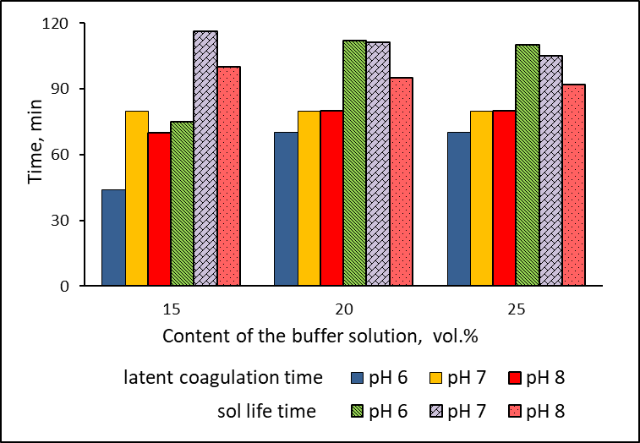

Fig. 1. Dependence of latent coagulation time and sol viability on the buffer solution content
The lowest latent coagulation time was observed for sols with buffer solution additives pH 6, and an increase in this parameter with increasing buffer solution content was also noted. For compositions with pH 7 and 8, this characteristic was at the same level.
For all the studied compositions, the viability of the sols was high (on average 2 h) and was satisfactory for high-quality application to the surface of the material and the formation of a homogeneous coating. It can be assumed that the phosphate buffer solution enhances the effect of the acetate solution, which is formed when mixing acetic acid and liquid glass. In this case, the viability of the sols increases compared to compositions without additives. The directly proportional relationship between the content of buffer solutions and the solidification time of the sols can be explained by the effect of dilution.
Fig. 2 shows the infrared spectra of raw silica gels. For systems modified with phosphate buffer solutions with different pH and different contents, the spectra have an almost identical set of characteristic vibration bands.
а
b

Fig. 2. IR spectra of raw SiO₂ gels: unmodified (a) and with 20 % phosphate buffer solution with pH 6 (b)

All spectra have a broad absorption band in the range of 2800–3600 cm^{–1}, which characterizes the stretching vibrations of the O–H bonds. Deformation vibrations of hydroxyl groups are marked by peaks at 1410, 1540 and 1635 cm^{–1}. The effect of the buffer solution content on the intensity of these bands was not observed.
The stretching vibrations of the Si–O–Si bonds correspond to clearly pronounced absorption bands at 790, 1050 cm^{–1}, the deformation ≡Si–OH – at
970 cm^{–1}. The intensity of the band at 1050 cm^{–1} for the modified gels was somewhat higher compared to the pure sample. The absorption bands in the range of 400–460 cm^{–1}, which correspond to the deformation rotational vibrations of Si–O [4–7], are also more intense in the spectra of the gel with additives. The set of absorption bands of the vibrations of the Si–O, ≡Si–OH, О–Н bonds indicates the presence of polysilicic acid in the gel.
In the range of 650–800 cm^{–1}, vibrations of the P–O bonds were recorded, and in the range of 500–530 cm^{–1}, vibrations of the bonds in orthophosphate ions were observed. The asymmetric vibration of the P=O bond in the IR spectrum was recorded in the range of 1115–1300 cm^{–1} [4–7].
For the spectra of the gel with the addition of phosphate buffer solution, absorption bands were recorded at 2320 and 2360 cm^{–1}, which may correspond to vibrations of the P–H bonds.
The authors of [8] noted that the band at 1540 cm^{–1} may be characteristic of acetate, namely, it corresponds to vibrations of the C=O bond. In [8], it was also noted that the maximum at 1129 cm^{–1} corresponds to vibrations of the Si–O–P bonds.
Given this, it can be assumed that Si–O–P bonds are present in the experimental samples, that is, phosphate ions are incorporated into the siloxane framework of the gel coating.

6. Results of determining the fire-retardant efficiency of silicophosphate coating on wooden samples
Table 1 shows the results of determining the fire protection efficiency group of the coating and the flammability class for wood samples.

Table 1. Results of studies on determining the fire protection efficiency group and the flammability class for wood samples
pH of buffer solution | Volume fraction of buffer solution, % | Number of coating layers | Sample mass loss (120 s), % | Coating fire protection efficiency group | Δt_{max}, °C | Time to reach maximum temperature, c | Sample mass loss during the time until reaching the maximum temperature, % | Combustibility
Untreated sample |  |  | 26,4 | - | 118 | 30 | 5,1 | flammable, combustible
6 | 15 | 1 | 12,7 | ІІ | 92 | 560 | 57 | сombustible,  highly flammable
6 | 15 | 2 | 10,1 | ІІ | 45 | 300 | 20 | highly flammable
6 | 15 | 3 | 9,1 | ІІ | 91 | 430 | 33,5 | combustible,  highly flammable
6 | 20 | 1 | 7,5 | І | 73 | 480 | 30,9 | combustible,  highly flammable
6 | 20 | 2 | 7,7 | І | 92 | 590 | 30 | combustible,  highly flammable
6 | 20 | 3 | 10,5 | ІІ | 100 | 310 | 31,2 | combustible,  highly flammable
6 | 25 | 1 | 6,8 | І | 56 | 300 | 16,8 | highly flammable
6 | 25 | 2 | 10,2 | ІІ | 90 | 600 | 55,8 | combustible, highly flammable
6 | 25 | 3 | 12 | ІІ | 82 | 180 | 17,9 | combustible, medium flammability
7 | 15 | 1 | 8,8 | І | 38 | 300 | 21,5 | highly flammable
7 | 15 | 2 | 8,9 | І | 90 | 620 | 54 | combustible, highly flammable
7 | 15 | 3 | 8,9 | І | 72 | 540 | 46 | combustible, highly flammable
7 | 20 | 1 | 8,2 | І | 65 | 340 | 26,4 | combustible, highly flammable
7 | 20 | 2 | 8,8 | І | 103 | 600 | 51,2 | combustible, highly flammable
7 | 20 | 3 | 9,3 | ІІ | 90 | 590 | 52,2 | combustible, highly flammable
7 | 25 | 1 | 7,9 | І | 70 | 250 | 19,9 | combustible, highly flammable
7 | 25 | 2 | 8,8 | І | 45 | 300 | 21,5 | hardly flammable
7 | 25 | 3 | 6,2 | І | 93 | 370 | 28,9 | combustible, highly flammable

The best results were obtained for coatings based on compositions with a 25 % content of phosphate buffer solution with pH 7 (the mass loss of samples is 6.2–7.9 %).
It is worth noting that the effectiveness of a fire-retardant coating depends not only on the acidity of the composition, but also on the number of its applied layers.
The addition of a phosphate buffer solution with an acidity of 6 makes it possible to significantly reduce mass loss during fire tests (Fig. 3): increasing the content to 20 % halves the mass loss under the conditions of using a single-layer coating.

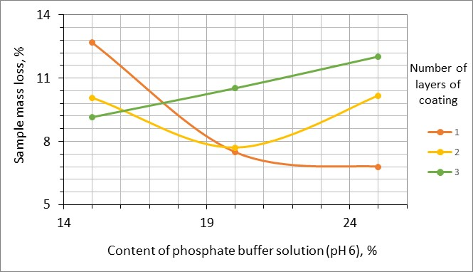

Fig. 3. Effect of the content of phosphate buffer solution with pH 6 on the mass loss of samples during fire tests for 2 min

In the case of applying a two-layer coating at the point of 20 % phosphate buffer solution with pH 6, a decrease in mass loss is also observed (from 10 to 8 %). In the case of applying a three-layer coating, mass loss increases with increasing buffer solution content. This is consistent with the assumption of the influence of the quality of coating application and the accumulation of micro-inhomogeneities in the coating, which leads to the formation of cracks and an increase in mass loss of samples.
In the case of using a buffer solution with pH 7: the mass loss of the samples after 2 min of testing is less than 9 %, and increasing the buffer solution content to 25 % leads to a further decrease in mass loss.
The obtained data also confirm the fact that the resistance of the coating to fire is also affected by the amount of water used to prepare the composition and after gel formation may be in the interglobule space of the coating. Water evaporates, cooling the surface of the material, therefore, for a single-layer coating in the first minutes of fire exposure, mass loss is minimal (Fig. 4).

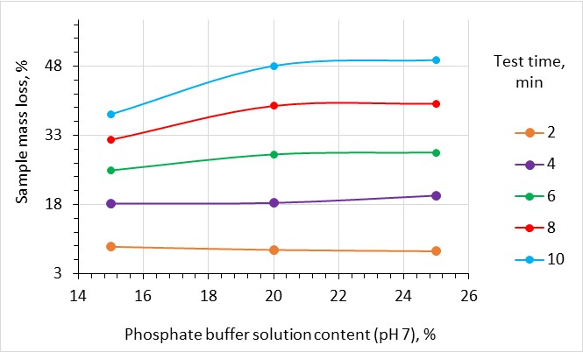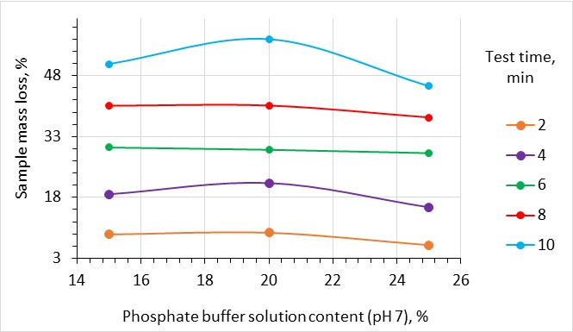
a
b
Fig. 4. Influence of the content of phosphate buffer solution with pH 7 and the time of fire test on the mass loss of samples with single-layer (a) and three-layer (b) coating

After the water evaporates, the cooling effect no longer occurs, so an increase in mass loss is observed.
This conclusion is confirmed by the results shown in Fig. 4 (b): the three-layer coating is less homogeneous, so some water can remain in the lower layers of the coating and gradually, over time, evaporate, and cooling the coating surface.

7. Effect of phosphate buffer solutions on the fire protection of extruded polystyrene foam
Extruded polystyrene foam is widely used for thermal insulation of buildings, because it has a much lower price than expanded polystyrene. But, despite the fact that the composition of extruded polystyrene foam contains flame retardants (as indicated in the certificate), under the influence of fire, active combustion is observed within 3 s. During combustion, the foam melts flows down in burning drops, sticks to cold surfaces, continuing to burn.
Compositions containing phosphate buffer solutions were used to apply a fire-retardant coating to extruded polystyrene foam. Table 2 shows the results of fire tests for samples of extruded polystyrene foam.
One of the main advantages of using a fire-retardant coating of the studied composition is the prevention of the formation of burning drops during the combustion of extruded polystyrene foam. The use of a phosphate buffer solution with a pH of 8 allowed increasing the ignition time of the sample to 5–6 s, which was almost twice as high as the corresponding parameter for untreated XPS. At the same time, the combustion process proceeded slowly and without sticking to the metal surface of the installation.
Modifying the silicic acid sols by buffer solutions with a pH of 6–7 significantly increased the fire resistance of the foam - combustion began after 7–8 s, the samples did not support combustion or did not ignite at all. Mass losses ranged from 0–1.95 % depending on the number of layers of the applied coating and the pH of the solution.

Table 2. Fire test results for extruded polystyrene foam samples
pH of buffer solution | Volume fraction of buffer solution, % | Number of coating layers | Sample mass loss, % | Ignition time, s | Note
Untreated sample |  |  | - | 3 | actively burned with the formation of burning drops
6 | 15 | 1 |  | 7 | burned without the formation of burning droplets
6 | 15 | 2 |  | 7 | burned without the formation of burning droplets
6 | 15 | 3 | 0,36 | - | did not burn
6 | 20 | 1 | 1,18 | - | did not burn
6 | 20 | 2 | 1,12 | - | did not burn
6 | 20 | 3 | 0 | - | did not burn
6 | 25 | 1 | 0,78 | 4 | did not support combustion
6 | 25 | 2 | - | 4 | burned without the formation of burning droplets
6 | 25 | 3 | - | 8 | burned without the formation of burning droplets
7 | 15 | 1 | 1,14 | - | did not burn
7 | 15 | 2 | - | 8 | burned without the formation of burning droplets
7 | 15 | 3 | - | 7 | burned without the formation of burning droplets
7 | 20 | 1 | 0,77 | - | did not burn
7 | 20 | 2 | 1,12 | - | did not burn
7 | 20 | 3 | 1,07 | - | did not burn
7 | 25 | 1 | - | 5 | burned without the formation of burning
7 | 25 | 2 | 1,95 | 6 | did not support combustion
7 | 25 | 3 | - | 5 | burned without the formation of burning
8 | 15 | 1 | 1,55 | 6 | did not support combustion
8 | 15 | 2 | 2,18 | 5 | did not support combustion
8 | 15 | 3 | - | 5 | burned without the formation of burning
8 | 20 | 1 | - | 6 | burned without the formation of burning
8 | 20 | 2 | 1,14 | - | did not burn
8 | 20 | 3 | - | 5 | burned without the formation of burning
8 | 25 | 1 | 1,19 | - | did not burn
8 | 25 | 2 | - | 5 | burned without the formation of burning
8 | 25 | 3 | 1,8 | - | did not burn

Examination of the surface of the samples under a microscope after testing showed the absence of cracks, i.e. shrinkage of the samples occurred without peeling of the coating (Fig. 5).

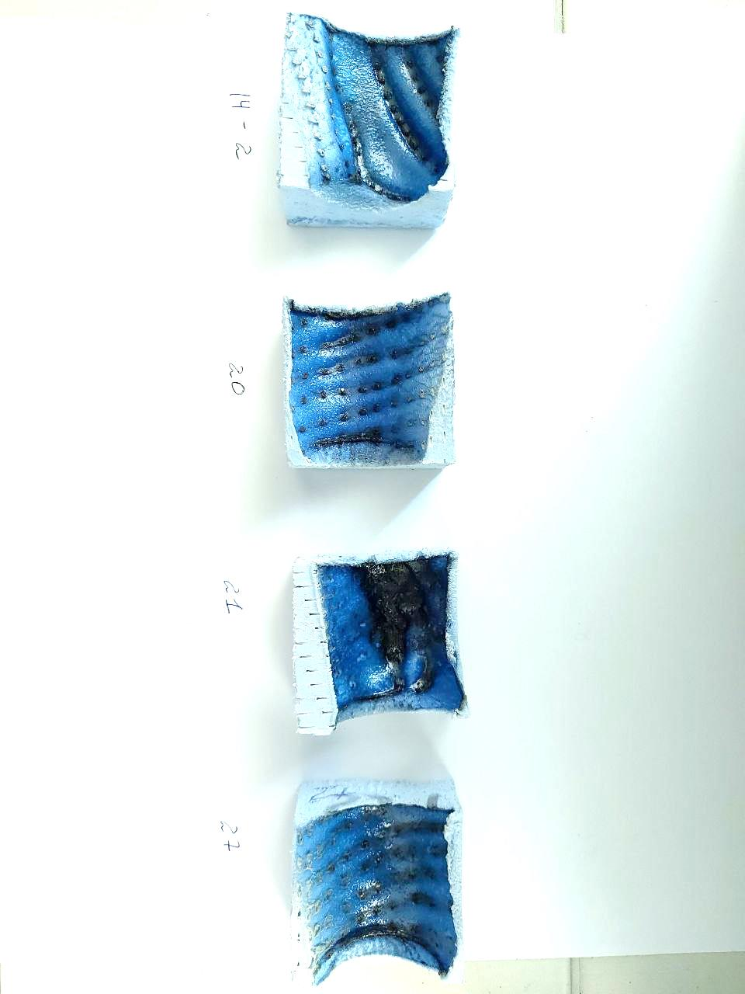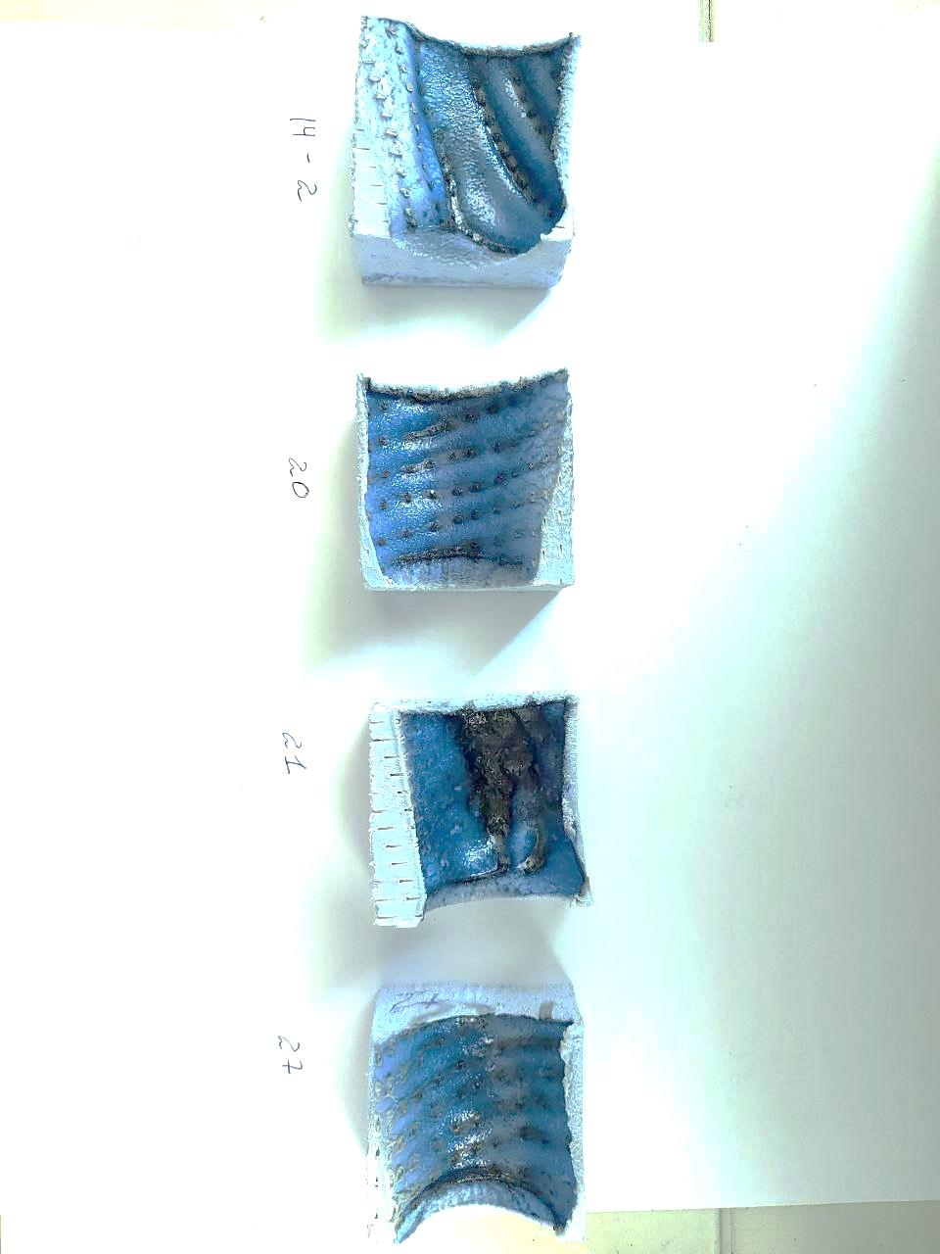

Fig. 5. Appearance of extruded polystyrene samples after fire tests

The best performance indicators of the fire-retardant coating were demonstrated by compositions with a 20 % phosphate buffer solution content with pH 6 and 7: during the action of fire, the samples did not ignite, their volume decreased, but the mass was stable.

8. Discussion of the results of a study of the influence of phosphate buffer systems on the fire-retardant effectiveness of coatings
The use of infrared spectroscopy to analyze the phase composition of the fire-retardant composition allowed us to draw an important conclusion regarding the incorporation of phosphate ion into the siloxane chain of polysilicic acid. This allows us to control the mechanism of the gelation process (Fig. 1), because it is the structure of the siloxane polymer that affects the integrity of the fire-retardant coating during fire exposure: under the conditions of linear polycondensation, an elastic coating is formed, which, together with the base, can change its shape without the formation of cracks. The mechanism of polycondensation can be determined by comparing the values ​​of the ratio of the intensity of the absorption band of the vibration of the –Si–O–Si– bonds at 1050 cm^{–1} to its width in the IR spectra of gel samples obtained at different pH values ​​of the buffer solution. It can be assumed that when using a buffer solution with pH 6, H+ ions are released, which, together with the H+ ions of the acetate buffer solution formed during the preparation of the composition, initiate network polycondensation. At pH 7, the buffer mixture of dihydrogen phosphate and sodium hydrogen phosphate releases a smaller number of hydrogen ions, therefore, linear polycondensation is initiated.
These assumptions are confirmed by the results of fire studies of wooden samples: the lowest mass losses were observed in wood samples treated with compositions containing 25% phosphate buffer solution with pH 7. In addition, water molecules can be retained in the interglobule space, which, when evaporated, have a cooling effect on the surface of the material, thereby preventing combustion and flame spread.
The developed compositions of fire-retardant compositions can be used to protect both cellulose-containing material (wood) and synthetic material, which practically does not contain functional groups that can initiate the formation of covalent bonds between the coating surface and the synthetic base. Sufficient durability allows high-quality coating application on the surface of finishing materials. High adhesion of the coating to the base is explained by the formation of covalent bonds with the cellulose-containing base. When using the developed compositions for fire protection of expanded polystyrene, the coating is also sewn to the base, but there are very few such bonds, so the main influence on maintaining the density of the coating is provided by good adhesion of the composition to the expanded polystyrene surface (Fig. 5).
It has been established that a sharp heating of the coating surface leads to its partial melting, due to which the coating acquires thermoplasticity, therefore it does not crack and does not peel off from the polystyrene base during its shrinkage under the action of fire. This is what can explain the fact that extruded polystyrene foam will not support combustion if it gets into the fire zone. Fig. 5 shows that the melted surface is observed only in the fire zone. In the event of cracks in the coating, point fires of polystyrene foam appear, which spread very quickly, which leads to complete combustion of the sample. It must be said that even in this case, burning drops are not formed.
The minimum percentage of mass loss of samples (Table 2) after fire tests allows us to conclude that the optimal level of acidity of the composition should be pH7.
For extruded polystyrene foam, optimal results were obtained with compositions with a 20% additive content with pH 6 and 7. Uniform burning of the samples also indicated the formation of a homogeneous coating. A separate role is played by the high sodium content in the fire-retardant composition. As is known, compounds of this metal are fusible. During the action of fire, the coating passes into a visco-plastic state, thereby increasing adhesion and preventing the formation of cracks in the coating.
Further research will be aimed at conducting tests in conditions as close as possible to real operational conditions, in particular, it is planned to develop a specialized laboratory facility to assess the fire-retardant efficiency of building finishing materials used for thermal insulation by mounting on external wall structures.

8. Conclusions
1. The influence of phosphate buffer solutions on the gelation processes in silicic acid sols was investigated. It was found that modification with phosphate buffer solutions ensures the survivability of the compositions for ~2 hours. The set of characteristic absorption bands of infrared spectra proved the homogeneity of the structure of the obtained fire-retardant coating, and the formation of heat-resistant silicophosphate bonds was also confirmed.
2. It was found that during fire tests, the mass loss of expanded polystyrene fluctuated in the range of 0–1.95 % depending on the number of layers of the applied coating; the mass loss of wooden samples with the developed coating was 6.2–7.9 %. Thus, it can be argued that silicic acid sol modified with a phosphate buffer solution with pH 7 (at 20–25 % additive content) can potentially be considered as a universal fire retardant composition for building materials such as wood and extruded polystyrene foam.

References
1. Zhang, C., Jiang, Y., Li, S., Huang, Z., Zhan, X., Ma, N., Tsai, F. (2022). Recent trends of phosphorus-containing flame retardants modified polypropylene composites processing. Heliyon, 8(11), e11225. doi: 10.1016/ j.heliyon.2022.e11225.
2. Varganici, C., Rosu, L., Bifulco, A., Rosu, D., Mustata, F., Gaan, S. (2022). Recent advances in flame retardant epoxy systems from reactive DOPO–based phosphorus additives. Polymer Degradation and Stability, 202, 110020. doi: 10.1016/j.polymdegradstab.2022.110020
3. Zheng, T., Wang, W., Liu, Y. (2021). A novel phosphorus‐nitrogen flame retardant for improving the flame retardancy of polyamide 6: Preparation, properties, and flame retardancy mechanism. Polymers for Advanced Technologies, 32(6), 2508–2516. doi:10.1002/pat.5281
4. Yan, Y., Liang, B. (2019) Flame-retardant behavior and mechanism of a DOPO-based phosphorus–nitrogen flame retardant in epoxy resin. High Performance Polymers, 31(8), 885-892. doi:10.1177/0954008318805794
5. Giraudo, M., Dubé, M., Lépine, M., Gagnon, P., Douville, M., Houde, M. (2017). Multigenerational effects evaluation of the flame retardant tris(2-butoxyethyl) phosphate (TBOEP) using Daphnia magna. Aquatic Toxicology, 190, 142–149. doi: 10.1016/j.aquatox.2017.07.003
6. Bolshova, T., Shvartsberg, V., Shmakov, A. (2021). Synergism of trimethylphosphate and carbon dioxide in extinguishing premixed flames. Fire Safety Journal, 125, 103406. doi: 10.1016/j.firesaf.2021.103406
7. Chupeau, Z., Bonvallot, N., Mercier, F., Bot, B. L., Chevrier, C., Glorennec, P. (2020). Organophosphorus Flame Retardants: A global review of indoor contamination and human exposure in Europe and epidemiological evidence. International Journal of Environmental Research and Public Health, 17(18), 6713. doi: 10.3390/ijerph17186713
8. Giraudo, M., Douville, M., Houde, M. (2015). Chronic toxicity evaluation of the flame retardant tris (2-butoxyethyl) phosphate (TBOEP) using Daphnia magna transcriptomic response. Chemosphere, 132, 159–165. doi: 10.1016/j.chemosphere.2015.03.028
9. Wang, K., Huang, W., Tian, Q., Tu, C., Yang, C., Yan, W. (2024). Multiple synergistic effects of silicon-containing flame retardants and DOPO derivative enhance the flame retardancy of epoxy resin. Polymer-Plastics Technology and Materials, 63(10), 1294-1305. doi: 10.1080/25740881.2024.2328617
10. Lysak, N., Skorodumova, O., Chernukha, A. (2023). Development of a fire-proof coating containing silica for polystyrene. Problems of Emergency Situations, 2(38), 192–202. doi: 10.52363/2524-0226-2023-38-10
11. Skorodumova, О., Tarakhno, O., Chebotareva, O., Bajanova, K. (2022). Silicon protective coatings for textile materials based on liquid glass. Problems of Emergency Situations, 1(35), 109–119. doi: 10.52363/2524-0226-2022-35-8
12. DSTU 4479:2005 Rechovyny vohnezakhysni vodorozchynni dlia derevyny. Zahalni tekhnichni vymohy ta metody vyprobuvannia. Chynnyi z 01.10.2006. Кyiv: Derzhspozhyvstandart Ukrainy, 2006, 17.
13. DSTU 8829:2019. Pozhezhovybukhonebezpechnist rechovyn i materialiv. Nomenklatura pokaznykiv i metody yikhnoho vyznachennia. Klasyfikatsiia. Chynnyi z 01.01.2020. Vyd. ofits. Kyiv: UkrNDNTs, 2020, 75.
14. Karan, R., Pal, P., Maiti, P., Das, K. (2021). Structure, properties and in-vitro response of SiO₂-Na₂O-CaO-P₂O₅ system, based glass-ceramics after partial replacement of Na₂O by Li₂O. Journal of Non-Crystalline Solids, 556, 120554. doi: 10.1016/j.jnoncrysol.2020.120554
15. Zribi, M., Baklouti, S. (2021). Investigation of phosphate based geopolymers formation mechanism. Journal of Non-Crystalline Solids, 562, 120777. doi: 10.1016/j.jnoncrysol.2021.120777
16. Stýskalík, A., Škoda, D., Moravec, Z., Babiak, M., Barnes, C. E., Pinkas, J. (2015). Control of micro/mesoporosity in non-hydrolytic hybrid silicophosphate xerogels. Journal of Materials Chemistry. A, Materials for Energy and Sustainability, 3(14), 7477–7487. doi: 10.1039/C4TA06823H

УДК 614.8

Н. М. Лисак, аспірант, викладач каф. (ORCID 0000-0001-5338-4704)
О. Б. Скородумова, д.т.н., проф., проф. каф. (ORCID 0000-0002-8962-0155)
А. А. Чернуха, к.т.н., доц., доц. каф. (ORCID 0000-0002-0365-3205)
А. Я. Шаршанов, д.т.н., доц., доц. каф. (ORCID 0000-0002-9115-3453)
Я. М. Гончаренко, к.т.н., ст. викл. каф. (ORCID 0000-0002-1766-3244)
С. М. Щербак, к.т.н., ст. викладач каф. (ORCID 0000-0003-1133-0120)

Національний університет цивільного захисту України, Черкаси, Україна

СИЛІКОФОСФАТНІ ВОГНЕЗАХИСНІ КОМПОЗИЦІЇ ДЛЯ БУДІВЕЛЬНИХ ОЗДОБЛЮВАЛЬНИХ МАТЕРІАЛІВ

Розроблено склад силікофосфатної композиції на основі рідкого скла для вогнезахисту будівельних оздоблювальних матеріалів. Композиції готували змішуванням водних розчинів рідкого скла та оцтової кислоти з додаванням фосфатних буферних розчинів з рН 6–8. Методом інфрачервоної спектроскопії досліджено фазовий склад експериментальних композицій та встановлено утворення зв'язків Si–O–P, що свідчить про вбудовування фосфат-іонів в силоксановий каркас гелів полікремнієвої кислоти. Встановлено, що на механізм поліконденсації впливають величина рН фосфатного буферного розчина, а також його вміст. Використання буферного розчину з рН 6 призводе до ініціалізації переважно сітчастої поліконденсації в золях рідкого скла. Підвищення рН до 7–8 забезпечує лінійну поліконденсацію полікремнієвої кислоти, що підвищує однорідність гелевого покриття, надає еластичності та підвищує його вогнезахисну дію. Живучість усіх досліджених композицій в середньому складає 2 години і практично не залежить від вмісту буферного розчину. Проведені вогневі випробування показали, що найкращі вогнезахисні властивості мають системи з вмістом буферного розчину 20–25 % з рН 7, які забезпечують максимальну стійкість до дії вогню та мінімальні втрати маси зразків під час дії високих температур. Для таких композицій встановлено
І групу вогнезахисної ефективності, а обробка ними зразків деревини дозволяє перевести матеріал до групи «важкогорючі». Зразки екструдованого пінополістиролу, вкриті розробленими композиціями не горять, відзначається відсутність палаючих крапель. Отримані результати підкреслюють перспективність подальшого розвитку таких систем для захисту будівельних матеріалів.
Ключові слова: кремнезем, вогнезахисні покриття, фосфатні буфери, будівельні матеріали, термостійкість, вогнестійкість, деревина, пінополістирол

Література
1. Zhang C., Jiang Y., Li S., Huang Z., Zhan X., Ma N., Tsai F. Recent trends of phosphorus-containing flame retardants modified polypropylene composites processing. Heliyon. 2022. Vol. 11, № 8. P. e11225. doi: 10.1016/ j.heliyon.2022.e11225.
2. Varganici C., Rosu L., Bifulco A., Rosu D., Mustata F., Gaan S. Recent advances in flame retardant epoxy systems from reactive DOPO–based phosphorus additives. Polymer Degradation and Stability. 2022. № 202. P. 110020. doi: 10.1016/j.polymdegradstab.2022.110020
3. Zheng T., Wang W., Liu Y. A novel phosphorus‐nitrogen flame retardant for improving the flame retardancy of polyamide 6: Preparation, properties, and flame retardancy mechanism. Polymers for Advanced Technologies. 2021. Vol. 6, № 32. P. 2508–2516. doi:10.1002/pat.5281
4. Yan Y., Liang B. Flame-retardant behavior and mechanism of a DOPO-based phosphorus–nitrogen flame retardant in epoxy resin. High Performance Polymers. 2019. Vol. 8, № 31. P. 885-892. doi:10.1177/0954008318805794
5. Giraudo M., Dubé M., Lépine M., Gagnon P., Douville M., Houde M. Multigenerational effects evaluation of the flame retardant tris(2-butoxyethyl) phosphate (TBOEP) using Daphnia magna. Aquatic Toxicology. 2017. № 190. P. 142–149. doi: 10.1016/j.aquatox.2017.07.003
6. Bolshova T., Shvartsberg V., Shmakov A. Synergism of trimethylphosphate and carbon dioxide in extinguishing premixed flames. Fire Safety Journal. 2021. № 125. P. 103406. doi: 10.1016/j.firesaf.2021.103406
7. Chupeau Z., Bonvallot N., Mercier F., Bot B. L., Chevrier C., Glorennec P. Organophosphorus Flame Retardants: A global review of indoor contamination and human exposure in Europe and epidemiological evidence. International Journal of Environmental Research and Public Health. 2020. Vol. 17, № 18. P. 6713. doi: 10.3390/ijerph17186713
8. Giraudo M., Douville M., Houde M. Chronic toxicity evaluation of the flame retardant tris (2-butoxyethyl) phosphate (TBOEP) using Daphnia magna transcriptomic response. Chemosphere. 2015. № 132. P. 159–165. doi: 10.1016/j.chemosphere.2015.03.028
9. Wang K., Huang W., Tian Q., Tu C., Yang C., Yan W. Multiple synergistic effects of silicon-containing flame retardants and DOPO derivative enhance the flame retardancy of epoxy resin. Polymer-Plastics Technology and Materials. 2024. Vol. 63, № 10. P. 1294-1305. doi: 10.1080/25740881.2024.2328617
10. Lysak N., Skorodumova O., Chernukha A. Development of a fire-proof coating containing silica for polystyrene. Problems of Emergency Situations. 2023. Vol. 2, № 38. P. 192–202. doi: 10.52363/2524-0226-2023-38-10
11. Skorodumova О., Tarakhno O., Chebotareva O., Bajanova K. Silicon protective coatings for textile materials based on liquid glass. Problems of Emergency Situations. 2022. Vol. 1, № 35. P. 109–119. doi: 10.52363/2524-0226-2022-35-8
12. ДСТУ 4479:2005 Речовини вогнезахисні водорозчинні для деревини. Загальні технічні вимоги та методи випробування. Чинний з 01.10.2006. Київ: Держспоживстандарт України, 2006. 17 с.
13. ДСТУ 8829:2019. Пожежовибухонебезпечність речовин і матеріалів. Номенклатура показників і методи їхнього визначення. Класифікація. Чинний з 01.01.2020. Вид. офіц. Київ: УкрНДНЦ, 2020. 75 с.
14. Karan R., Pal P., Maiti P., Das K. Structure, properties and in-vitro response of SiO₂-Na₂O-CaO-P₂O₅ system, based glass-ceramics after partial replacement of Na₂O by Li₂O. Journal of Non-Crystalline Solids. 2021. № 556. P. 120554. doi: 10.1016/j.jnoncrysol.2020.120554
15. Zribi M., Baklouti S. Investigation of phosphate based geopolymers formation mechanism. Journal of Non-Crystalline Solids. 2021. № 562. P. 120777. doi: 10.1016/j.jnoncrysol.2021.120777
16. Stýskalík A., Škoda D., Moravec Z., Babiak M., Barnes C. E., Pinkas J. Control of micro/mesoporosity in non-hydrolytic hybrid silicophosphate xerogels. Journal of Materials Chemistry. A, Materials for Energy and Sustainability. 2015. Vol. 14, № 3. P. 7477–7487. doi: 10.1039/C4TA06823H

Лисак Наталія Михайлівна
Аспірант
Кафедра спеціальної хімії та хімічної технології
Національний університет цивільного захисту України
вул. Онопрієнка, 8, м. Черкаси, Україна, 18034
Е-mail: n.m.lysak@gmail.com
Контактний тел. : 0667810695
Кількість статей в загальнодержавних базах даних - 3
Кількість статей в міжнародних базах даних - 1
Номер ORCID: http://orcid.org 0000-0001-5338-4704

Скородумова Ольга Борисівна
Доктор технічних наук, професор
Кафедра спеціальної хімії та хімічної технології
Національний університет цивільного захисту України
вул. Онопрієнка, 8, м. Черкаси, Україна, 18034
Е-mail: skorodumova.o.b@gmail.com
Контактний тел.: 050-51-569-53
Кількість статей в загальнодержавних базах даних - 80
Кількість статей в міжнародних базах даних - 30
Номер ORCID: http://orcid.org/0000-0002-8962-0155

Чернуха Антон Андрійович
Кандидат технічних наук, доцент
Кафедра пожежної та рятувальної підготовки
Національний університет цивільного захисту України
вул. Онопрієнка, 8, м. Черкаси, Україна, 18034
E-mail: an_cher@nuczu.edu.ua
Контактний телефон: +380954491282
Кількість публікацій в іноземних індексованих виданнях – 15
Номер ORCID: http://orcid.org/0000-0002-0365-3205

Шаршанов Андрій Янович
Доктор технічних наук, доцент
Кафедра спеціальної хімії та хімічної технології
Національний університет цивільного захисту України
вул. Онопрієнка, 8, м. Черкаси, Україна, 18034
Е-mail: sharshanov59@gmail.com
Контактний тел.: 0930291169
Кількість статей в загальнодержавних базах даних - 50
Кількість статей в міжнародних базах даних - 10
Номер ORCID: http:// orcid.org 0000-0002-9115-3453

Гончаренко Яна Миколаївна
Кандидат технічних наук, старший викладач
Кафедра спеціальної хімії та хімічної технології
Національний університет цивільного захисту України
вул. Онопрієнка, 8, м. Черкаси, Україна, 18034
Е-mail: 7002818@gmail.com
Контактний тел.: 050-51-569-53
Кількість статей в загальнодержавних базах даних - 20
Кількість статей в міжнародних базах даних - 5
Номер ORCID: http://orcid.org/ 0000-0002-1766-3244

Щербак Сергій Миколайович
Кандидат технічних наук, доцент
Кафедра пожежної та рятувальної підготовки
Національний університет цивільного захисту України
вул. Онопрієнка, 8, м. Черкаси, Україна, 18034
E-mail: shcherbak_serhii@nuczu.edu.ua
Контактний телефон: +380507086263
Кількість публікацій в іноземних індексованих виданнях – 5
Номер ORCID: https://orcid.org/0000-0003-1133-0120
Lysak Nataliia
Postgraduate
Department of Special Chemistry and Chemical Technology
National University of Civil Defence of Ukraine
Onopriyenka St., 8, Cherkasy, Ukraine, 18034
Е-mail: n.m.lysak@gmail.com
Contact tel .: 0667810695
Number of articles in national databases - 3
Number of articles in international databases - 1
ORCID Number: http://orcid.org 0000-0001-5338-4704

Skorodumova Olga
Doctor of Technical Sciences, Professor
Department of Special Chemistry and Chemical Technology
National University of Civil Defence of Ukraine
Onopriyenka St., 8, Cherkasy, Ukraine, 18034
E-mail: skorodumova.o.b@gmail.com
Contact tel .: 050-51-569-53
Number of articles in national databases - 80
Number of articles in international databases - 30
ORCID Number: http://orcid.org/0000-0002-8962-0155

Chernukha Anton
PhD, Associate Professor
Department of Fire and Rescue Training
National University of Civil Defence of Ukraine
Onopriyenka St., 8, Cherkasy, Ukraine, 18034
E-mail: an_cher@nuczu.edu.ua
Contact tel.: +380954491282
The number of articles in international databases – 15
Number ORCID: http://orcid.org/0000-0002-0365-3205

SharshanovAndriyYanovych
Doctor of Technical Sciences, Associate Professor, teacher
Department of Special Chemistry and Chemical Technology
NationalUniversity of Civil Defence of Ukraine
Onopriyenka St., 8, Cherkasy, Ukraine, 18034
Е-mail: sharshanov59@gmail.com
Contact tel.: 093-029-11-69
Number of articles in national databases - 50
Number of articles in international databases - 10
ORCID Number: http://orcid.org/0000-0002-9115-3453

Goncharenko Yana
PhD, Associate Professor
Department of Special Chemistry and Chemical Technology
National University of Civil Defence of Ukraine
Onopriyenka St., 8, Cherkasy, Ukraine, 18034
E-mail: 7002818@gmail.com
Contact tel .: 050-51-569-53
Number of articles in national databases - 20
Number of articles in international databases - 5
ORCID Number: http://orcid.org/0000-0002-1766-3244

Shcherbak Serhiy Mykolayovych
PhD, Associate Professor
Department of Fire and Rescue Training
National University of Civil Defense of Ukraine
Onopriyenka St., 8, Cherkasy, Ukraine, 18034
E-mail: shcherbak_serhii@nuczu.edu.ua
Contact phone: +380507086263
Number of publications in foreign indexed publications – 5
ORCID number: http://orcid.org/0000-0003-1133-0120

