Modeling the Thermal Effects of Fire on Steel-Reinforced Concrete Slabs with a Corrugated Profile
FEDCHENKO Svitlana ^{1, a*}, NUIANZIN Oleksandr ^{1, b}, STEPANKO Vitalii ^{1, c}, VEDULA Serhii ^{1, d}
¹ National University of Civil Protection of Ukraine, 8 Onopriienko str., Cherkasy, Ukraine, 18034
ªfedchenko_svitlana@nuczu.edu.ua, ^{b}nuianzin_oleksandr@nuczu.edu.ua, ^{c}stepanenko_vitalii@nuczu.edu.ua, ^{d}vedula_serhii@nuczu.edu.ua
Keywords: fire, safety, steel reinforced concrete, modeling, slab, furnace, heating, fire resistance, testing, temperature.

Abstract. The aim of the work was to determine the possibility of not taking into account the orientation (vertical or horizontal) of the studied elements of steel-reinforced concrete slabs with a corrugated profile during their heating in a modular small-sized fire furnace. The work investigated the temperature distributions on the outer surface of the corrugated ceiling profile of a steel-reinforced concrete slab of horizontal orientation simulated in the fire furnace chamber. To create geometric models of the fire furnace chamber and the studied element, a CAD software complex was used. To solve the heat engineering problem, mathematical (numerical) methods were used, based on solving systems of differential equations of continuous media such as the Navier-Stokes equation and the Fourier heat conductivity equation. According to the results obtained, the temperature distribution on the outer surface of the steel profile of the reinforced concrete slab is uniform, the temperature deviation in different places on the surface does not exceed 7%. The maximum temperature on the heating surface of the steel profile of the reinforced concrete slab in the last minute of computer simulation reached 921 ºС and the average temperature at this time over the entire surface of the structure was 917ºС. To determine the appropriate orientation of the test sample during fire tests, a comparison of the obtained temperature distributions on the outer surface of the corrugated profile of a horizontally placed reinforced concrete slab with the temperature distributions on the outer surface of the corrugated profile of a vertically placed reinforced concrete slab, which were given in the previous work was made. Analysis of the average surface temperatures of the corrugated profile of a reinforced concrete slab of horizontal and vertical orientation showed that the temperature distribution over the surface of the profile was uniform in both cases and the results obtained show good reproducibility of the experiment during computer simulation. And the orientation of the tested elements does not affect the temperature distribution over the outer surface of the corrugated profile of a reinforced concrete slab in the simulated furnace.
1 Formulation of the Problem
Steel-reinforced concrete structures are widely used both in the field of public construction and in the creation of protective structures of civil protection. The use of monolithic floors on profiled decks allows for high construction speed and reduced resource consumption, which allows for increased economic efficiency of construction and obtaining a durable rigid ribbed floor. Steel profiled sheets are used first as a fixed formwork, and then they work together with concrete as external reinforcement.
Reinforced concrete floors provide increased rigidity and load-bearing capacity of the structure. However, the effect of high temperatures on these building structures has not been sufficiently studied. Incorrect determination of the required fire resistance class of these building structures at the design stage of buildings leads to an increase in the number of dangerous factors in the event of a fire, associated with the task of harming human life or health, property or the environment.
It is advisable to increase the accuracy of methods for assessing the fire resistance of reinforced concrete floors to guarantee the stability of buildings in fire conditions.
2 Analysis of Recent Achievements and Publications
Fire resistance studies of reinforced concrete floors in Ukraine are carried out in accordance with standardized requirements [1, 2]. The possibility of calculating and conducting experiments to assess fire resistance is provided. Calculation methods for predicting the performance of reinforced concrete floors do not have such restrictions on the size of the samples under study, but are limited to the use of coefficients when determining changes in the thermal characteristics of materials. This work describes a method for combining the positive aspects of both calculations and experiments when assessing the fire resistance of reinforced concrete slabs with a corrugated profile.
The basis and input data of this work were the studies conducted in [3]. The process of conducting a real experiment on heating a steel-reinforced concrete fragment of a slab with a corrugated profile in a small-sized fire furnace was recreated using computer gas-hydrodynamics tools. In this case, the slab was placed vertically. A logical question arose whether the orientation of the slab affects the uniformity of heating of its surface and, as a result, the adequacy of the result. According to the results obtained in [3], the outer surface of the corrugated ceiling profile of a steel-reinforced concrete structure was heated relatively evenly. The higher temperature was observed in even parts, the lower one - at the bends. The maximum temperature on the heated surface of the load-bearing wall reached 840 ºС and the average temperature at this point in time over the entire surface of the structure was 820 ºС. The temperature distribution over the surface of the structure was uniform, the deviation in different places on the surface did not exceed 5%.
In [4], the thermal effect of fire on fragments of reinforced concrete columns is described based on their heating under the standard temperature regime of fire in a small-sized fire furnace and it is shown that the orientation (vertical or horizontal) of the studied sample of the building structure does not affect the heating of the surface. However, the behavior of building structures with corrugated steel profiles has not been investigated.
In [5], a finite element model of thermal calculation of a refractory reinforced concrete slab is described, which can partially or completely replace the experimental assessment of fire resistance. However, the dependence of the parameters of the construction and tuning of the model to assess the adequacy of the results obtained was not taken into account.
Also, the finite element model was used to solve the thermal problem in computer modeling of the thermal effect of fire on a multi-hollow reinforced concrete floor in the study [6]. However, this work did not consider steel-reinforced concrete floors.
The work [7] is devoted to the study of the insulating effect of the connection of a concrete slab and a steel deck under fire conditions. The results obtained indicate that during the impact of fire, the steel deck is disconnected and separated from the concrete, and the gap formed as a result of this separation provides a layer of insulating distance. However, it has not been investigated how this can be affected by the orientation in space during heating under the standard temperature regime of fire.
For a more extensive analysis of the thermal impact of fire based on the results of computer modeling, the results of research work [8] were considered. This work describes the process of mathematical modeling of the behavior of a vertically arranged glass panel when it is heated on one side under the influence of a standard temperature regime of fire. During mathematical modeling, the temperature distribution over the surface of the glass panel was uniform. However, for a comparative analysis of the results obtained, the behavior of a horizontally oriented glass panel was not investigated.
In [9], the results of mathematical modeling of the calculation of the temperature of steel plates with a fireproof coating under the influence of a hydrocarbon fire are described. A flame retardant was used as a fireproof coating. However, reinforced concrete as a fireproof layer and the behavior of steel plates under such conditions were not considered.
Thus, the analysis of literary sources showed that the behavior of steel-reinforced concrete floors under the influence of fire has not been fully studied and is adequate for further scientific research.
3 Problem Statement and its Solution
The aim of the work was to determine the possibility of not taking into account the orientation (vertical or horizontal) of the studied elements of reinforced concrete slabs with a corrugated profile during their heating in a modular small-sized fire furnace.
To achieve the goal, it is necessary to solve the following tasks:
- To conduct computer modeling of the heating of a horizontally placed reinforced concrete slab and to analyze the temperature distributions on the outer surface of the corrugated ceiling profile.
- To compare the obtained temperature distributions on the outer surface of a horizontally placed reinforced concrete slab with the temperature distributions on the outer surface of the corrugated profile of a similar, but vertically placed slab.
- To draw a conclusion about the influence of the slab orientation (vertically or horizontally) on the adequacy of the obtained results. To outline the prospects for further research.
4 Methods
The structural diagram of the slab that was used to conduct a study on the heating of the surface of a horizontal steel-reinforced concrete slab is presented in Fig. 1. A similar design was used in the work [3].

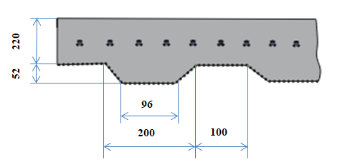

Fig. 1. Structural diagram of the studied sample.

A CAD software package was used to create geometric models of the furnace chamber and the test sample.

This 3-D model, similar to that described in [3], was imported into the CFD software environment. To solve the thermal problem, mathematical (computational) methods were used, based on solving systems of differential equations of continuous media such as the Navier-Stokes equation and the Fourier heat conduction equation.
Figure 2 shows the result of creation of a computational grid for computer modeling..

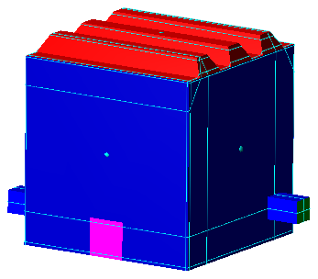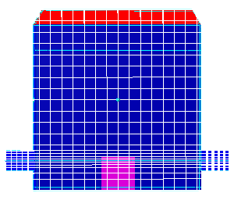
3
2
4
1
2
a b
Fig. 2. View of the 3-D model: a – furnace chamber; b – computational grid model of the furnace chamber: 1 – furnace chamber; 2 – temperature measurement points near the surface of the corrugated profile; 3 – temperature control point in the furnace chamber; 4 – grid thickening area in the burner area.

During the modeling of the furnace chamber and the steel-reinforced concrete slab with a corrugated profile, a computational grid was created. The dimensions of the grid cells ensured sufficient accuracy of the results obtained, since their denser placement was built in the places where the burners were located, which allowed taking into account heat transfer near the surface of the solid body and the features of intense turbulent flows in the places of combustion. To control the temperature indicators in the test sample and in the furnace chamber, the thermocouples were located in such a way that it was possible to study the temperature distributions on the unheated side of the corrugated profile of the steel-reinforced concrete slab, namely: on flat sections of the corrugated profile - 5, on bent sections of the corrugated profile - 4, in the thickness of the concrete layer adjacent to the corrugated profile - 3 and to control the temperature in the furnace chamber - 2.
Fig. 3 presents a visualization of the first minute of the heat flow calculation depending on the test time.
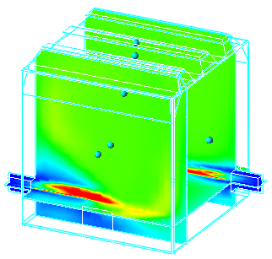
Fig. 3. Visualization of the calculation process.

During the calculation of the heat flow, the temperature indicators at the control points of the furnace chamber were constantly monitored and compared with the curve of the standard temperature regime of the fire [2]. To ensure the standard requirements, the intensity of the supply of combustible material was adjusted during the calculation process. To study the adequacy of the obtained results, mathematical statistics methods were applied using comparative analysis of calculation data on the study of a steel-reinforced concrete slab with a corrugated steel profile of vertical and horizontal configuration.
5 Presentation of the main material of the study with a full justification of the results
To conduct the study in the CFD software complex during computer modeling, a pulsating combustion model was selected, which is advisable to use in the case when the gross reaction rate is determined by the relative dispersion of the concentration of restored volatiles [10]. During the study, temperature indicators were obtained in the furnace chamber (Fig. 4) and on the outer surface of the corrugated ceiling profile of a horizontally placed steel-reinforced concrete slab (Fig. 5).
Ѳ,℃

V
N
3
2
1
τ, min.
Fig. 4. Temperature regime in the furnace chamber during computer simulation: 1 – 3 – average temperature at the control points of the furnace chamber; V, N – upper and lower limits of the standard temperature regime.

The chamber of the simulated furnace was heated in such a way that the standard temperature regime of the fire was ensured as accurately as possible. [1].

τ, min.
3
V
N
1
2
Ѳ,℃

Fig. 5. Data on the heating of the surface of the corrugated profile: 1 – average temperature in the upper part; 2 – average temperature in the middle part; 3 – average temperature in the lower part; V, N – upper and lower limits of the standard temperature regime.

Analysis of Fig. 5 showed that the outer surface of the corrugated steel profile of the reinforced concrete slab is heated relatively evenly. The smooth surface of the corrugated profile has a higher temperature than the temperature on the surface of the bent profile elements. The temperature difference of the surface of the corrugated profile of the reinforced concrete slab is within 7%.
The obtained data are compared with the results of studies of the heating of the slab during vertical placement [3]. The quality and uniformity of heating of the studied samples is uniform in both cases and does not depend on the orientation of the studied building structures in space (vertically or horizontally).
Fig. 6 shows the temperature distribution on the surface of the studied sample of a steel-reinforced concrete slab with a corrugated profile at different heating times.

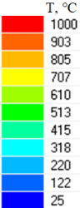
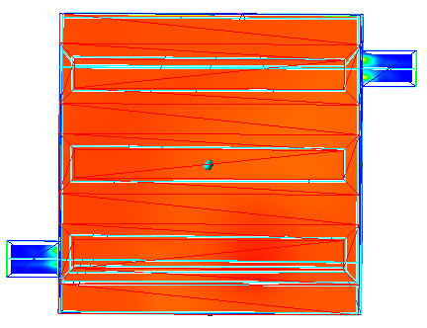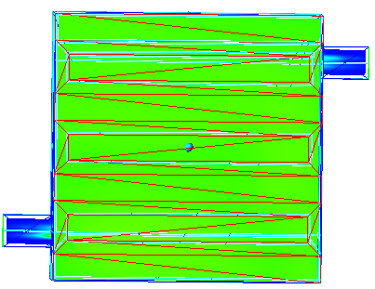
a b
Fig. 6. Temperature distribution on the heating surface of a steel-reinforced concrete slab with a corrugated profile at different heating times: a – 60 minutes; b – 10 minutes.

According to the obtained data on the temperature distribution on the heating surface of the corrugated profile of a horizontally placed steel-reinforced concrete slab, the temperature regimes in the furnace chamber and on the heating surface of the tested sample, the following conclusions can be drawn:
- the temperature effect of the fire on the heating surface of the corrugated profile of the steel-reinforced concrete slab in the chamber of the fire furnace corresponded to the standard temperature curve of the fire (Fig. 4);
- the maximum temperature on the heating surface of the corrugated profile of the steel-reinforced concrete slab at the last minute of computer modeling reached 921 °C, and the average temperature at this time over the entire surface of the structure was 917 °C (Fig. 6);
- the temperature distribution over the surface of the corrugated profile of the steel-reinforced concrete slab is uniform, the deviation in different places of the surface does not exceed 7% (Fig. 4 – 5).
To determine the appropriate orientation of the test sample during fire tests, the obtained temperature distributions on the outer surface of the corrugated profile of a horizontally placed steel-reinforced concrete slab were compared with the temperature distributions on the outer surface of the corrugated profile of a vertically placed steel-reinforced concrete slab, which are given in [3].
Figure 7 shows the temperature distribution curves in the furnace chamber during the simulation of the tested elements of horizontal and vertical placement [3].

τ, min.
Ѳ,℃
2
N
Fig. 7. Average temperature in the furnace chamber during the simulation of the studied elements of horizontal and vertical placement: V, N – upper and lower limits of the standard temperature regime; 1 – average temperature in the furnace chamber during the simulation of the horizontally placed test sample; 2 – average temperature in the furnace chamber during the simulation of the vertically placed test sample.

According to the results of the comparative analysis of temperature regimes in the furnace chamber during computer simulation of a steel-reinforced concrete slab with a corrugated profile, it is possible to state the reliability of the obtained results. Since, in both cases, the temperature regime was within the standard temperature regime, and the temperature distribution across the chamber of the simulated furnace was uniform [3].
A comparative analysis of the values ​​of the average surface temperatures of the corrugated profile of a steel-reinforced concrete slab of horizontal and vertical orientation was also carried out. The obtained results are shown in Fig. 8.

Ѳ,℃
V
N
2
1
τ, min.
Fig. 8. Average surface temperature of the corrugated profile of a steel-reinforced concrete slab: V, N – upper and lower limits of the standard temperature regime; 1 – average surface temperature of the corrugated profile of a horizontally placed steel-reinforced concrete slab; 2 – average surface temperature of the corrugated profile of a vertically placed steel-reinforced concrete slab.

The research conducted in this work proves that the temperature distribution on the surface of the corrugated profile is uniform regardless of the orientation in space. The obtained data show a positive reproducibility of the experimental results during computer modeling. Therefore, it is possible to disregard the orientation (vertical or horizontal) of the studied elements of steel-reinforced concrete slabs with a corrugated profile during their heating in a modular small-sized fire furnace [3].
6 Conclusions
The work carried out computer simulation of the heat and mass transfer process for heating a steel-reinforced concrete slab with a corrugated profile of horizontal orientation. The obtained data were analyzed and compared with the results of computer simulation of a similar slab, but with a vertical orientation [3].
- Computer simulation of heating of a horizontally placed reinforced concrete slab was carried out and temperature distributions on the outer surface of the corrugated ceiling profile were analyzed. The temperature distribution on the outer surface of the corrugated profile of a horizontally placed reinforced concrete slab is uniform, the temperature deviation in different places of the surface does not exceed 7%. The maximum temperature on the heating surface of the corrugated profile of the reinforced concrete slab at the last minute of computer simulation reached 921 ºС, and the average temperature at this time over the entire surface of the structure was 917 ºС.
- The obtained temperature distributions on the outer surface of a horizontally placed steel-reinforced concrete slab were compared with the temperature distributions on the outer surface of a corrugated profile of a similar, but vertically placed slab. Analysis of the average surface temperatures of the corrugated profile of a steel-reinforced concrete slab of horizontal and vertical orientation showed that the temperature distribution on the surface of the profile was uniform in both cases. The obtained data show positive reproducibility of the experimental results during computer simulation.
- According to the results obtained, it is possible to disregard the orientation (vertical or horizontal) of the studied elements of steel-reinforced concrete slabs with a corrugated profile during their heating in a modular small-sized fire furnace.

References

[1] DSTU EN 1363-1:2023 Vyprobuvannya na vohnestiykist. Chastyna 1. Zahalni vymohy [Fire resistance test. Part 1. General requirements] (EN 1363-1:2020, IDT). https://online.budstandart.com/ua/catalog/doc-page.html?id_doc=103325
[2] EN 1994-1-2 (2005) (English): Eurocode 4: Design of composite steel and concrete structures – Part 1-2: General rules - Structural fire design [Authority: The European Union Per Regulation 305/2011, Directive 98/34/EC, Directive 2004/18/EC]. https://www.phd.eng.br/wp-content/uploads/2015/12/en.1994.1.2.2005.pdf
[3] Stepanenko V. Study of the influence of the configuration of a small-dimensioned fire installation on the uniformity of heating of the surface of a steel-reinforced concrete slab. Scientific bulletin: Civil protection and fire safety, 1 (2(18)) 2024. Р. 4-12; https://journals.indexcopernicus.com/api/file/viewByFileId/2109543
[4] Nuianzin O.M., Kozak A.A., Yanishevskyi V.E., Kryshtal V.M. Study of the thermal effect of fire on fragments of reinforced concrete columns based on the results of experimental tests. Strength of Materials and Theory of Structures: Scientific-andtechnical collected articles. – K.: KNUBA, № 112. 2024. Р. 202-208. https://doi.org/10.32347/2410-2547.2024.112
[5] Kovalov, A., Purdenko, R., Otrosh, Y., Tomenko, V., Rashkevich, N., Shcholokov, E., Pidhornyy, M., Zolotova, N., Suprun, O. Assessment of fire resistance of fireproof reinforced concrete structures. Eastern-European Journal of Enterprise Technologies, 5 (1 (119)) 2022. Р. 53–61. https://doi.org/10.15587/1729-4061.2022.266219
[6] Kovalov A., Otrosh Y., Poklonskyi V., Semkiv O. & Tomenko M. Research of fire resistance of fire protected reinforced concrete structures. Trans Tech Publications Ltd. In Materials Science Forum. 2022. Volume 1066. P. 224–232.
https://doi.org/10.4028/p-5nb606
[7] Shivam Sharma, Varun Teja Vaddamani, Anil Agarwal. Insulation effect of the concrete slab-steel deck interface in fire conditions and its influence on the structural fire behavior of composite floor systems Fire Safety Journal. April 2019. 1 Volume 105. Р. 79-91. DOI: 10.1016/j.firesaf.2019.02.006
[8] Nekora, V., Pozdieiev, S., Nekora, O., Fedchenko, S., Nignyk, V., Novhorodchenko, A., Shnal, T. Determining the behavior of a glass panel under heating conditions during a fire. Eastern-European Journal of Enterprise Technologies, 1 (1 (133)) 2025. Р. 52–61. https://doi.org/10.15587/1729-4061.2025.320431
[9] Kovalov, А. , YOtrosh, Y., Chernenko, O., Zhuravskij, M., Anszczak, M. Modeling of non-stationary heating of steel plates with fire-protective coatings in ansys under the conditions of hydrocarbon fire temperature mode. Trans Tech Publications Ltd, Switzerland. Materials Science Forum Submitted. Forum. Vol. 1038. P. 514-523 https://doi:10.4028/www.scientific.net/MSF.1038.514
[10] Haldinov, M., Peshko, V., Rindyuk, D., Chernousenko, O., & Lementar, S. (2018). CFD-sim ulation of th e pyrolysis process of high-tem perature decomposition of raw materials of plant origin in household solid-fuel boilers. Scientific Works of NUFT 2018. Volume 24. Issue 2 https://nuft.edu.ua/doi/doc/swnuft/2018/2/20.pdf

